***This is a bonus Web chapter

CHAPTER 40

JTable and JTree

Objectives
- To display tables using JTable (§40.2).
- To process rows and columns using TableModel, DefaultTableModel, TableColumnModel, DefaultTableColumnModel, and ListSelectionModel (§§40.3-40.5).
- To enable auto sort and filtering on table model (§40.4).
- To add rows and columns, delete rows and columns in a table (§40.5).
- To render and edit table cells using the default renderers and editors (§40.6).
- To render and edit table cells using the custom renderers and editors (§40.7).
- To handle table model events (§40.8).
- To display data in a tree hierarchy using JTree (§40.9).
- To model the structure of a tree using using TreeModel and DefaultTreeModel (§40.10).
- To add, remove, and process tree nodes using TreeNode, MutableTreeNode, and DefaultMutableTreeNode (§40.11).
- To select tree nodes and paths using TreeSelectionModel and DefaultTreeSelectionModel (§40.12).
- To render and edit tree nodes using the default and custom renderers and editors (§40.14).
40.1 Introduction
The preceding chapter introduced the model-view architecture, Swing MVC, and the models in JSpinner, JList, and JComboBox. This chapter introduces JTable and JTree, and how to use the models to process data in JTable and JTree.

40.2 JTable
JTable is a Swing component that displays data in rows and columns in a two-dimensional grid, as shown in Figure 40.1.

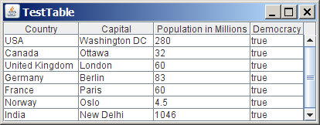

Figure 40.1
JTable displays data in a table.
JTable doesn't directly support scrolling. To create a scrollable table, you need to create a JScrollPane and add an instance of JTable to the scroll pane. If a table is not placed in a scroll pane, its column header will not be visible, because the column header is placed in the header of the view port of a scroll pane.

JTable has three supporting models: a table model, a column model, and a list-selection model. The table model is for storing and processing data. The column model represents all the columns in the table. The list-selection model is the same as the one used by JList for selecting rows, columns, and cells in a table. JTable also has two useful supporting classes, TableColumn and JTableHeader. TableColumn contains the information on a particular column. JTableHeader can be used to display table header. Each column has a default editor and renderer. You can also create a custom editor by implementing the TableCellEditor interface, and create a custom renderer by implementing the TableCellRenderer interface. The relationship of these interfaces and classes is shown in Figure 40.2.

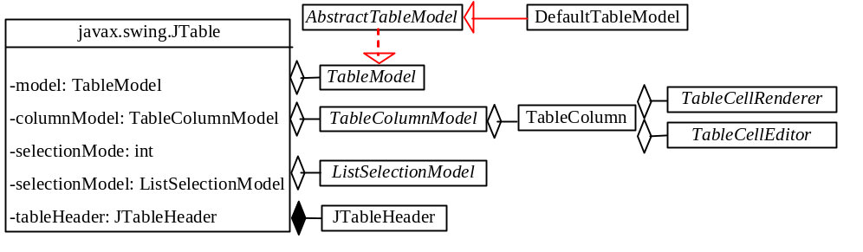

Figure 40.2
JTable contains many supporting interfaces and classes.
NOTE: All the supporting interfaces and classes for JTable are grouped in the javax.swing.table package.
Figure 40.3 shows the constructors, properties, and methods of JTable.

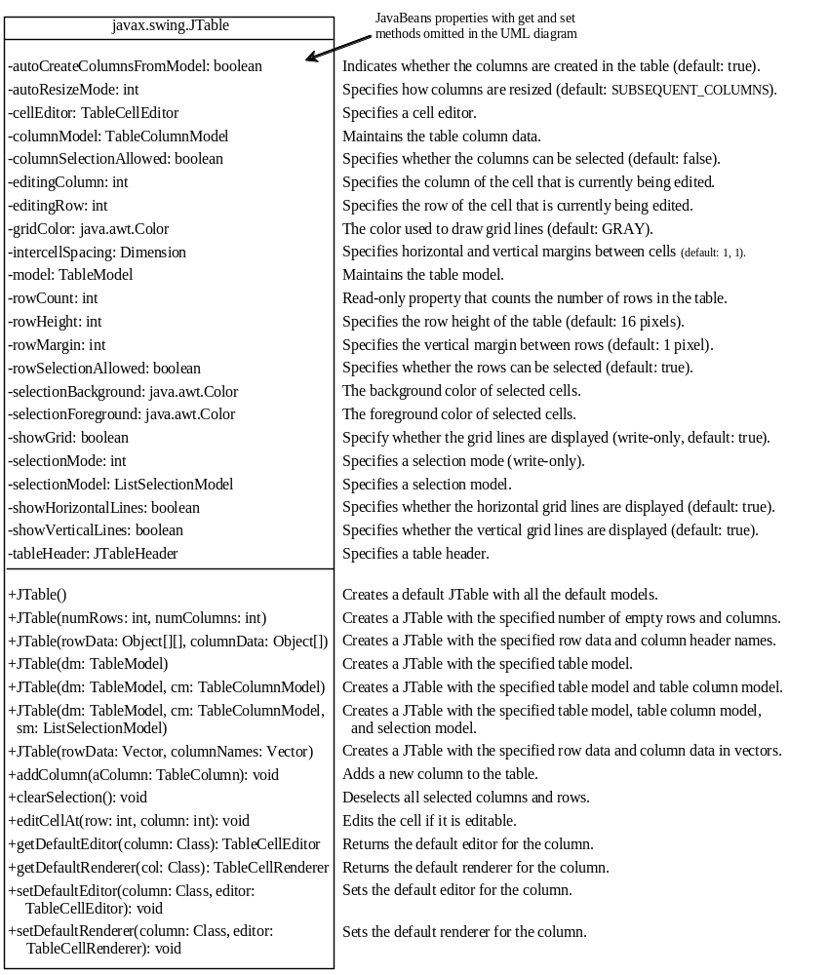

Figure 40.3
The JTable class is for creating, customizing, and manipulating tables.
The JTable class contains seven constructors for creating tables. You can create a table using its no-arg constructor, its models, row data in a two-dimensional array, and column header names in an array, or row data and column header names in vectors. Listing 40.1 creates a table with the row data and column names (line 20) and places it in a scroll pane (line 23). The table is displayed in Figure 40.1.

Listing 40.1 TestTable.java
<margin note line 5: column names>
<margin note line 9: row data>
<margin note line 20: create table>
<margin note line 23: scroll pane>
<margin note line 25: main method omitted>

1 import javax.swing.*;
2
3 public class TestTable extends JApplet {
4 // Create table column names
5 private String[] columnNames =
6 {"Country", "Capital", "Population in Millions", "Democracy"};
7
8 // Create table data
9 private Object[][] data = {
10 {"USA", "Washington DC", 280, true},
11 {"Canada", "Ottawa", 32, true},
12 {"United Kingdom", "London", 60, true},
13 {"Germany", "Berlin", 83, true},
14 {"France", "Paris", 60, true},
15 {"Norway", "Oslo", 4.5, true},
16 {"India", "New Delhi", 1046, true}
17 };
18
19 // Create a table
20 private JTable jTable1 = new JTable(data, columnNames);
21
22 public TestTable() {
23 add(new JScrollPane(jTable1));
24 }
25 }

NOTE
<margin note: autoboxing>
Primitive type values such as 280 and true in line 10 are autoboxed into new Integer(280) and new Boolean(true).
JTable is a powerful control with a variety of properties that provide many ways to customize tables. All the frequently used properties are documented in Figure 40.3. The autoResizeMode property specifies how columns are resized (you can resize table columns but not rows). Possible values are:

JTable.AUTO_RESIZE_OFF

JTable.AUTO_RESIZE_LAST_COLUMN

JTable.AUTO_RESIZE_SUBSEQUENT_COLUMNS

JTable.AUTO_RESIZE_NEXT_COLUMN

JTable.AUTO_RESIZE_ALL_COLUMNS

The default mode is JTable.AUTO_RESIZE_SUBSEQUENT_COLUMNS. Initially, each column in the table occupies the same width (75 pixels). With AUTO_RESIZE_OFF, resizing a column does not affect the widths of the other columns. With AUTO_RESIZE_LAST_COLUMN, resizing a column affects the width of the last column. With AUTO_RESIZE_SUBSEQUENT_COLUMNS, resizing a column affects the widths of all the subsequent columns. With AUTO_RESIZE_NEXT_COLUMN, resizing a column affects the widths of the next columns. With AUTO_RESIZE_ALL_COLUMNS, resizing a column affects the widths of all the columns.

Listing 40.2 gives an example that demonstrates the use of several JTable properties. The example creates a table and allows the user to choose an Auto Resize Mode, specify the row height and margin, and indicate whether the grid is shown. A sample run of the program is shown in Figure 40.4.

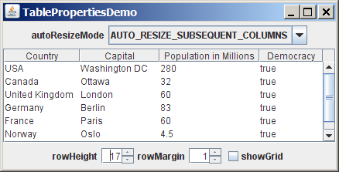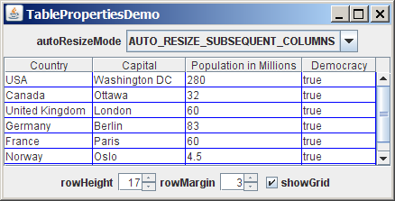

Figure 40.4
You can specify an autoresizing mode, the table’s row height and row margin, and whether to show the grid in the table.

Listing 40.2 TablePropertiesDemo.java
<margin note line 9: column names>
<margin note line 13: table data>
<margin note line 23: table>
<margin note line 27: spinners>
<margin note line 35: combo box>
<margin note line 40: create UI>
<margin note line 57: table properties>
<margin note line 64: spinner listener>
<margin note line 72: spinner listener>
<margin note line 80: check-box listener>
<margin note line 88: combo box listener>
<margin note line 109: main method omitted>

1 import java.awt.*;
2 import java.awt.event.*;
3 import javax.swing.*;
4 import javax.swing.event.*;
5
6 public class TablePropertiesDemo extends JApplet {
7 // Create table column names
8 private String[] columnNames =
9 {"Country", "Capital", "Population in Millions", "Democracy"};
10
11 // Create table data
12 private Object[][] rowData = {
13 {"USA", "Washington DC", 280, true},
14 {"Canada", "Ottawa", 32, true},
15 {"United Kingdom", "London", 60, true},
16 {"Germany", "Berlin", 83, true},
17 {"France", "Paris", 60, true},
18 {"Norway", "Oslo", 4.5, true},
19 {"India", "New Delhi", 1046, true}
20 };
21
22 // Create a table
23 private JTable jTable1 = new JTable(rowData, columnNames);
24
25 // Create two spinners
26 private JSpinner jspiRowHeight =
27 new JSpinner(new SpinnerNumberModel(16, 1, 50, 1));
28 private JSpinner jspiRowMargin =
29 new JSpinner(new SpinnerNumberModel(1, 1, 50, 1));
30
31 // Create a checkbox
32 private JCheckBox jchkShowGrid = new JCheckBox("showGrid", true);
33
34 // Create a combo box
35 private JComboBox jcboAutoResizeMode = new JComboBox(new String[]{
36 "AUTO_RESIZE_OFF", "AUTO_RESIZE_LAST_COLUMN",
37 "AUTO_RESIZE_SUBSEQUENT_COLUMNS", "AUTO_RESIZE_NEXT_COLUMN",
38 "AUTO_RESIZE_ALL_COLUMNS"});
39
40 public TablePropertiesDemo() {
41 JPanel panel1 = new JPanel();
42 panel1.add(new JLabel("rowHeight"));
43 panel1.add(jspiRowHeight);
44 panel1.add(new JLabel("rowMargin"));
45 panel1.add(jspiRowMargin);
46 panel1.add(jchkShowGrid);
47
48 JPanel panel2 = new JPanel();
49 panel2.add(new JLabel("autoResizeMode"));
50 panel2.add(jcboAutoResizeMode);
51
52 add(panel1, BorderLayout.SOUTH);
53 add(panel2, BorderLayout.NORTH);
54 add(new JScrollPane(jTable1));
55
56 // Initialize jTable1
57 jTable1.setAutoResizeMode(JTable.AUTO_RESIZE_OFF);
58 jTable1.setGridColor(Color.BLUE);
59 jTable1.setSelectionMode(ListSelectionModel.SINGLE_SELECTION);
60 jTable1.setSelectionBackground(Color.RED);
61 jTable1.setSelectionForeground(Color.WHITE);
62
63 // Register and create a listener for jspiRowHeight
64 jspiRowHeight.addChangeListener(new ChangeListener() {
65 public void stateChanged(ChangeEvent e) {
66 jTable1.setRowHeight(
67 ((Integer)(jspiRowHeight.getValue())).intValue());
68 }
69 });
70
71 // Register and create a listener for jspiRowMargin
72 jspiRowMargin.addChangeListener(new ChangeListener() {
73 public void stateChanged(ChangeEvent e) {
74 jTable1.setRowMargin(
75 ((Integer)(jspiRowMargin.getValue())).intValue());
76 }
77 });
78
79 // Register and create a listener for jchkShowGrid
80 jchkShowGrid.addActionListener(new ActionListener() {
81 @Override
82 public void actionPerformed(ActionEvent e) {
83 jTable1.setShowGrid(jchkShowGrid.isSelected());
84 }
85 });
86
87 // Register and create a listener for jcboAutoResizeMode
88 jcboAutoResizeMode.addActionListener(new ActionListener() {
89 @Override
90 public void actionPerformed(ActionEvent e) {
91 String selectedItem =
92 (String)jcboAutoResizeMode.getSelectedItem();
93
94 if (selectedItem.equals("AUTO_RESIZE_OFF"))
95 jTable1.setAutoResizeMode(JTable.AUTO_RESIZE_OFF);
96 else if (selectedItem.equals("AUTO_RESIZE_LAST_COLUMN"))
97 jTable1.setAutoResizeMode(JTable.AUTO_RESIZE_LAST_COLUMN);
98 else if (selectedItem.equals
99 ("AUTO_RESIZE_SUBSEQUENT_COLUMNS"))
100 jTable1.setAutoResizeMode(
101 JTable.AUTO_RESIZE_SUBSEQUENT_COLUMNS);
102 else if (selectedItem.equals("AUTO_RESIZE_NEXT_COLUMN"))
103 jTable1.setAutoResizeMode(JTable.AUTO_RESIZE_NEXT_COLUMN);
104 else if (selectedItem.equals("AUTO_RESIZE_ALL_COLUMNS"))
105 jTable1.setAutoResizeMode(JTable.AUTO_RESIZE_ALL_COLUMNS);
106 }
107 });
108 }
109 }

If you know the row data in advance, creating a table using the constructor JTable(Object[][] rowData, Object[] columnNames) is convenient. As shown in line 23, a JTable is created using this constructor.

Two JSpinner objects (jspiRowHeight, jspiRowMargin) for selecting row height and row margin are created in lines 26-29. The initial value for jspiRowHeight is set to 16, which is the default property value for rowHeight. The initial value for jspiRowMargin is set to 1, which is the default property value for rowMargin. A check box (jchkShowGrid) is created with label showGrid and initially selected in line 32. A combo box for selecting autoResizeMode is created in lines 35-38.

The values of the JTable properties (autoResizeMode, gridColor, selectionMode, selectionBackground, and selectionForeground) are set in lines 57-61.

The code for processing spinners, check boxes, and combo boxes is given in lines 64-106.

40.3 Table Models and Table Column Models
<margin note: TableModel>
JTable delegates data storing and processing to its table data model. A table data model must implement the TableModel interface, which defines the methods for registering table model listeners, manipulating cells, and obtaining row count, column count, column class, and column name.

<margin note: AbstractTableModel>
The AbstractTableModel class provides partial implementations for most of the methods in TableModel. It takes care of the management of listeners and provides some conveniences for generating TableModelEvents and dispatching them to the listeners. To create a concrete TableModel, you simply extend AbstractTableModel and implement at least the following three methods:
- public int getRowCount()
- public int getColumnCount()
- public Object getValueAt(int row, int column)
<margin note: DefaultTableModel>
The DefaultTableModel class extends AbstractTableModel and implements these three methods. Additionally, DefaultTableModel provides concrete storage for data. The data are stored in a vector. The elements in the vector are arrays of objects, each of which represents an individual cell value. The methods in DefaultTableModel for accessing and modifying data are shown in Figure 40.5.

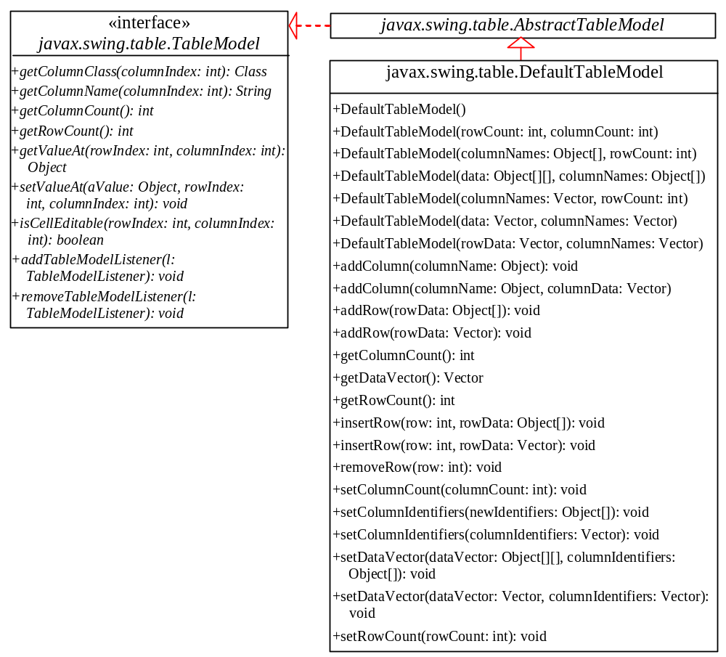

Figure 40.5
TableModel stores and manages data in a table and DefaultTableModel provides a default implementation for TableModel.
Listing 40.3 gives an example that demonstrates table models. The example creates a table model (line 16), plugs the model to the table (line 20), appends a row to the table (line 25), inserts a row before the first row (line 26), removes a row with index 1 (line 28), adds a new column (line 29), and sets new values at specified cells (lines 30-32). Figure 40.6 shows the output of the program.

Listing 40.3 TestTableModel.java

<margin note line 6: column names>
<margin note line 10: row data>
<margin note line 16: create table model>
<margin note line 20: create table>
<margin note line 23: scroll pane>
<margin note line 25: add row>
<margin note line 26: insert row>
<margin note line 28: remove row>
<margin note line 29: add column>
<margin note line 30: set value>
<margin note line 34: main method omitted>

1 import javax.swing.*;
2 import javax.swing.table.*;
3
4 public class TestTableModel extends JApplet {
5 // Create table column names
6 private String[] columnNames =
7 {"Country", "Capital", "Population in Millions", "Democracy"};
8
9 // Create table data
10 private Object[][] data = {
11 {"USA", "Washington DC", 280, true},
12 {"Canada", "Ottawa", 32, true}
13 };
14
15 // Create a model
16 private DefaultTableModel tableModel =
17 new DefaultTableModel(data, columnNames);
18
19 // Create a table
20 private JTable jTable1 = new JTable(tableModel);
21
22 public TestTableModel() {
23 add(new JScrollPane(jTable1));
24
25 tableModel.addRow(new Object[]{"France", "Paris", 60, true});
26 tableModel.insertRow(0, new Object[]
27 {"India", "New Delhi", 1046, true});
28 tableModel.removeRow(1);
29 tableModel.addColumn("Area");
30 tableModel.setValueAt(10, 0, 4);
31 tableModel.setValueAt(20, 1, 4);
32 tableModel.setValueAt(30, 2, 4);
33 }
34 }

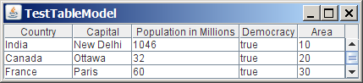

Figure 40.6
TableModel and DefaultTableModel contain the methods for adding, updating, and removing table data.
TableModel manages table data. You can add and remove rows through a TableModel. You can also add a column through a TableModel. However, you cannot remove a column through a TableModel. To remove a column from a JTable, you have to use a table column model.

<margin note: TableColumnModel>
Table column models manage columns in a table. They can be used to select, add, move, and remove table columns. A table column model must implement the TableColumnModel interface, which defines the methods for registering table column model listeners, and for accessing and manipulating columns, as shown in Figure 40.7.

<margin note: DefaultTableColumnModel>
DefaultTableColumnModel is a concrete class that implements TableColumnModel and PropertyChangeListener. The DefaultTableColumnModel class stores its columns in a vector and contains an instance of ListSelectionModel for selecting columns.

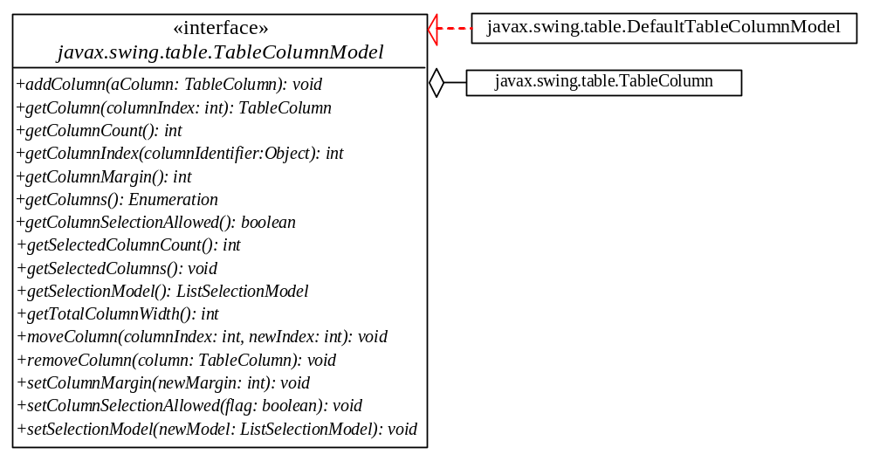

Figure 40.7

TableColumnModel manages columns in a table and DefaultTableColumnModel is a concrete implementation of it.

<margin note: TableColumn>
The column model deals with all the columns in a table. The TableColumn class is used to model an individual column in the table. An instance of TableColumn for a specified column can be obtained using the getColumn(index) method in TableColumnModel or the getColumn(columnIdentifier) method in JTable.

Figure 40.8 shows the properties, constructors, and methods in TableColumn for manipulating column width and specifying the cell renderer, cell editor, and header renderer.

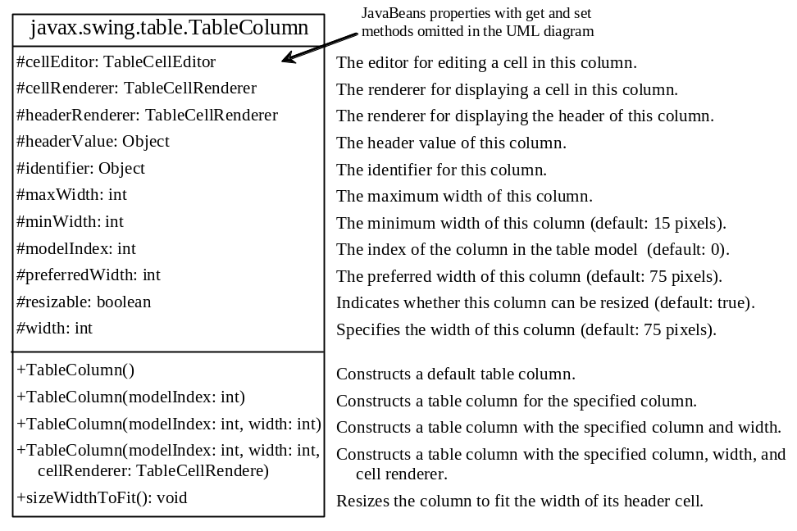

Figure 40.8
The TableColumn class models a single column.
Listing 40.4 gives an example that demonstrates table column models. The example obtains the table column model from the table (line 21), moves the first column to the second (line 22), and removes the last column (lines 23). Figure 40.9 shows the output of the program

Listing 40.4 TestTableColumnModel.java
<margin note line 6: column names>
<margin note line 10: row data>
<margin note line 16: create table>
<margin note line 19: scroll pane>
<margin note line 21: column model>
<margin note line 22: move a column>
<margin note line 23: remove a column>
<margin note line 25: main method omitted>

1 import javax.swing.*;
2 import javax.swing.table.*;
3
4 public class TestTableColumnModel extends JApplet {
5 // Create table column names
6 private String[] columnNames =
7 {"Country", "Capital", "Population in Millions", "Democracy"};
8
9 // Create table data
10 private Object[][] data = {
11 {"USA", "Washington DC", 280, true},
12 {"Canada", "Ottawa", 32, true}
13 };
14
15 // Create a table
16 private JTable jTable1 = new JTable(data, columnNames);
17
18 public TestTableColumnModel() {
19 add(new JScrollPane(jTable1));
20
21 TableColumnModel columnModel = jTable1.getColumnModel();
22 columnModel.moveColumn(0, 1);
23 columnModel.removeColumn(columnModel.getColumn(3));
24 }
25 }

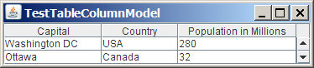

Figure 40.9
TableColumnModel contains the methods for moving and removing columns.
NOTE: Some of the methods defined in the table model and the table column model are also defined in the JTable class for convenience. For instance, the getColumnCount() method is defined in JTable, TableModel, and TableColumnModel, the addColumn method defined in the column model is also defined in the table model, and the getColumn() method defined in the column model is also defined in the JTable class.
<margin note: TableHeader>
JTableHeader is a GUI component that displayes the header of the JTable (see Figure 40.10). When you create a JTable, an instance of JTableHeader is automatically created and stored in the tableHeader property. By default, you can reorder the columns by dragging the header of the column. To disable it, set the reorderingAllowed property to false.

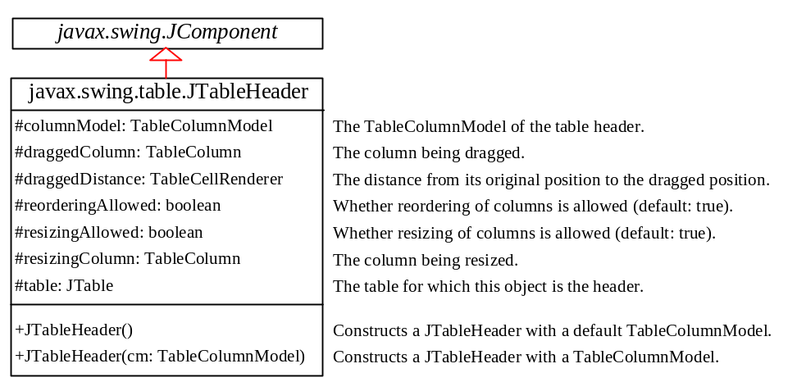

Figure 40.10

The JTableHeader class displays the header of the JTable.

40.4 Auto Sort and Filtering
Auto sort and filtering are two useful features. To enable auto sort on any column in a JTable, create an instance of TableRowSorter with a table model and set JTable’s rowSorter as follows:

<margin note: create a TableRowSorter>
TableRowSorter<TableModel> sorter =
new TableRowSorter<TableModel>(tableModel);

<margin note: setRowSorter>
jTable.setRowSorter(sorter);

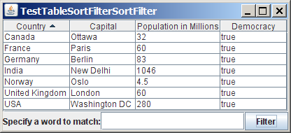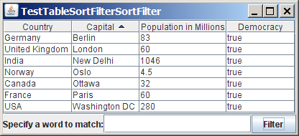
(a) (b)

Figure 40.11
(a) The table is sorted on Country. (b) The table is sorted on Capital.
When the table is displayed, you can sort the table by clicking a column head, as shown in Figure 40.11.

You can specify a filter to select rows in the table. The filter can be applied on one column or all columns. The javax.swing.RowFilter class contains several static methods for creating filters. You can use the regexFilter method to create a RowFilter with the specified regular expression. For example, the following statement creates a filter for the rows whose first column or second column begin with letter U.

<margin note: create a filter>
RowFilter rowFilter = RowFilter.regexFilter("U.*", int[]{0, 1});

The second argument in the regexFilter method specifies a set of column indices. If no indices are specified, all columns are searched in the filter.

<margin note: set filter in JTable>
To enable filtering, you have to associate a filter with a TableRowSorter, which is set to the JTable’s rowSorter property.

Listing 40.5 gives an example that demonstrates auto sort and filtering in JTable.

Listing 40.5 TestTableSortFilter.java

<margin note line 7: column names>
<margin note line 11: row data>
<margin note line 22: create table>
<margin note line 25: create TableRowSorter>
<margin note line 33: set sorter>
<margin note line 49: remove filter>
<margin note line 51: set a filter>
<margin note line 55: main method omitted>

1 import javax.swing.*;
2 import javax.swing.table.*;
3 import java.awt.BorderLayout;
4
5 public class TestTableSortFilter extends JApplet {
6 // Create table column names
7 private String[] columnNames =
8 {"Country", "Capital", "Population in Millions", "Democracy"};
9
10 // Create table data
11 private Object[][] data = {
12 {"USA", "Washington DC", 280, true},
13 {"Canada", "Ottawa", 32, true},
14 {"United Kingdom", "London", 60, true},
15 {"Germany", "Berlin", 83, true},
16 {"France", "Paris", 60, true},
17 {"Norway", "Oslo", 4.5, true},
18 {"India", "New Delhi", 1046, true}
19 };
20
21 // Create a table
22 private JTable jTable1 = new JTable(data, columnNames);
23
24 // Create a TableRowSorter
25 private TableRowSorter<TableModel> sorter =
26 new TableRowSorter<TableModel>(jTable1.getModel());
27
28 private JTextField jtfFilter = new JTextField();
29 private JButton btFilter = new JButton("Filter");
30
31 public TestTableSortFilter() {
32 // Enable auto sorter
33 jTable1.setRowSorter(sorter);
34
35 JPanel panel = new JPanel(new java.awt.BorderLayout());
36 panel.add(new JLabel("Specify a word to match:"),
37 BorderLayout.WEST);
38 panel.add(jtfFilter, BorderLayout.CENTER);
39 panel.add(btFilter, BorderLayout.EAST);
40
41 add(panel, BorderLayout.SOUTH);
42 add(new JScrollPane(jTable1), BorderLayout.CENTER);
43
44 btFilter.addActionListener(new java.awt.event.ActionListener() {
45 @Override
46 public void actionPerformed(java.awt.event.ActionEvent e) {
47 String text = jtfFilter.getText();
48 if (text.trim().length() == 0)
49 sorter.setRowFilter(null);
50 else
51 sorter.setRowFilter(RowFilter.regexFilter(text));
52 }
53 });
54 }
55 }

The example creates a TableRowSorter (line 25) and sets the sorter in jTable1 (line 33). The program lets the user enter a filter pattern from a text field, as shown in Figure 40.12. If nothing is entered, no filter is set (line 48). If a regex is entered, clicking the Filter button sets the filter to jTable1 (line 50).

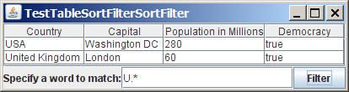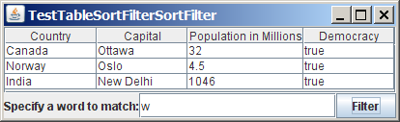
(a) (b)

Figure 40.12
(a) Filter the table with regex U.*. (b) Filter the table with regex w.
40.5 Case Study: Modifying Rows and Columns
This case study demonstrates the use of table models, table column models, list-selection models, and the TableColumn class. The program allows the user to choose selection mode and selection type, add or remove rows and columns, and save, clear, or restore the table, as shown in Figure 40.13a.

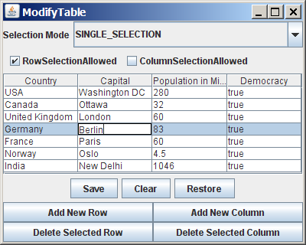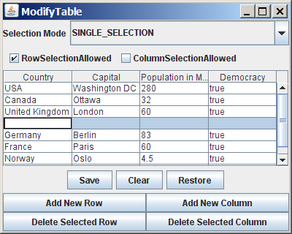
(a) (b)

Figure 40.13
You can add, remove, and modify rows and columns in a table interactively.
The Add New Row button adds a new empty row before the currently selected row, as shown in Figure 40.13b. If no row is currently selected, a new empty row is appended to the end of the table.

When you click the Add New Column button, an input dialog box is displayed to receive the title of the column, as shown in Figure 40.14a. The new column is appended in the table, as shown in Figure 40.14b.

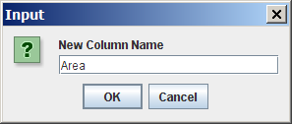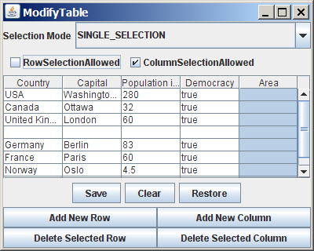
(a) (b)

Figure 40.14
You can add a new column in a table.
The Delete Selected Row button deletes the first selected row. The Delete Selected Column button deletes the first selected column.

The Save button saves the current table data and column names. The Clear button clears the row data in the table. The Restore button restores the saved table.

Listing 40.6 gives the program.

Listing 40.6 ModifyTable.java
<margin note line 10: column names>
<margin note line 14: table data>
<margin note line 25: table model>
<margin note line 29: table>
<margin note line 32: buttons>
<margin note line 42: combo box>
<margin note line 47: check boxes>
<margin note line 53: create UI>
<margin note line 93: add row>
<margin note line 104: add column>
<margin note line 112: delete row>
<margin note line 120: delete column>
<margin note line 132: save table>
<margin note line 148: clear table>
<margin note line 155: restore table>
<margin note line 173: row selection allowed>
<margin note line 181: column selection allowed>
<margin note line 190: choose selection mode>
<margin note line 209: get column names>
<margin note line 217: main method omitted>

1 import java.awt.*;
2 import java.awt.event.*;
3 import javax.swing.*;
4 import javax.swing.table.*;
5 import java.io.*;
6 import java.util.Vector;
7
8 public class ModifyTable extends JApplet {
9 // Create table column names
10 private String[] columnNames =
11 {"Country", "Capital", "Population in Millions", "Democracy"};
12
13 // Create table data
14 private Object[][] rowData = {
15 {"USA", "Washington DC", 280, true},
16 {"Canada", "Ottawa", 32, true},
17 {"United Kingdom", "London", 60, true},
18 {"Germany", "Berlin", 83, true},
19 {"France", "Paris", 60, true},
20 {"Norway", "Oslo", 4.5, true},
21 {"India", "New Delhi", 1046, true}
22 };
23
24 // Create a table model
25 private DefaultTableModel tableModel = new DefaultTableModel(
26 rowData, columnNames);
27
28 // Create a table
29 private JTable jTable1 = new JTable(tableModel);
30
31 // Create buttons
32 private JButton jbtAddRow = new JButton("Add New Row");
33 private JButton jbtAddColumn = new JButton("Add New Column");
34 private JButton jbtDeleteRow = new JButton("Delete Selected Row");
35 private JButton jbtDeleteColumn = new JButton(
36 "Delete Selected Column");
37 private JButton jbtSave = new JButton("Save");
38 private JButton jbtClear = new JButton("Clear");
39 private JButton jbtRestore = new JButton("Restore");
40
41 // Create a combo box for selection modes
42 private JComboBox jcboSelectionMode =
43 new JComboBox(new String[] {"SINGLE_SELECTION",
44 "SINGLE_INTERVAL_SELECTION", "MULTIPLE_INTERVAL_SELECTION"});
45
46 // Create check boxes
47 private JCheckBox jchkRowSelectionAllowed =
48 new JCheckBox("RowSelectionAllowed", true);
49 private JCheckBox jchkColumnSelectionAllowed =
50 new JCheckBox("ColumnSelectionAllowed", false);
51
52 public ModifyTable() {
53 JPanel panel1 = new JPanel();
54 panel1.setLayout(new GridLayout(2, 2));
55 panel1.add(jbtAddRow);
56 panel1.add(jbtAddColumn);
57 panel1.add(jbtDeleteRow);
58 panel1.add(jbtDeleteColumn);
59
60 JPanel panel2 = new JPanel();
61 panel2.add(jbtSave);
62 panel2.add(jbtClear);
63 panel2.add(jbtRestore);
64
65 JPanel panel3 = new JPanel();
66 panel3.setLayout(new BorderLayout(5, 0));
67 panel3.add(new JLabel("Selection Mode"), BorderLayout.WEST);
68 panel3.add(jcboSelectionMode, BorderLayout.CENTER);
69
70 JPanel panel4 = new JPanel();
71 panel4.setLayout(new FlowLayout(FlowLayout.LEFT));
72 panel4.add(jchkRowSelectionAllowed);
73 panel4.add(jchkColumnSelectionAllowed);
74
75 JPanel panel5 = new JPanel();
76 panel5.setLayout(new GridLayout(2, 1));
77 panel5.add(panel3);
78 panel5.add(panel4);
79
80 JPanel panel6 = new JPanel();
81 panel6.setLayout(new BorderLayout());
82 panel6.add(panel1, BorderLayout.SOUTH);
83 panel6.add(panel2, BorderLayout.CENTER);
84
85 add(panel5, BorderLayout.NORTH);
86 add(new JScrollPane(jTable1),
87 BorderLayout.CENTER);
88 add(panel6, BorderLayout.SOUTH);
89
90 // Initialize table selection mode
91 jTable1.setSelectionMode(ListSelectionModel.SINGLE_SELECTION);
92
93 jbtAddRow.addActionListener(new ActionListener() {
94 @Override
95 public void actionPerformed(ActionEvent e) {
96 if (jTable1.getSelectedRow() >= 0)
97 tableModel.insertRow(jTable1.getSelectedRow(),
98 new java.util.Vector<String>());
99 else
100 tableModel.addRow(new java.util.Vector<String>());
101 }
102 });
103
104 jbtAddColumn.addActionListener(new ActionListener() {
105 @Override
106 public void actionPerformed(ActionEvent e) {
107 String name = JOptionPane.showInputDialog("New Column Name");
108 tableModel.addColumn(name, new java.util.Vector());
109 }
110 });
111
112 jbtDeleteRow.addActionListener(new ActionListener() {
113 @Override
114 public void actionPerformed(ActionEvent e) {
115 if (jTable1.getSelectedRow() >= 0)
116 tableModel.removeRow(jTable1.getSelectedRow());
117 }
118 });
119
120 jbtDeleteColumn.addActionListener(new ActionListener() {
121 @Override
122 public void actionPerformed(ActionEvent e) {
123 if (jTable1.getSelectedColumn() >= 0) {
124 TableColumnModel columnModel = jTable1.getColumnModel();
125 TableColumn tableColumn =
126 columnModel.getColumn(jTable1.getSelectedColumn());
127 columnModel.removeColumn(tableColumn);
128 }
129 }
130 });
131
132 jbtSave.addActionListener(new ActionListener() {
133 @Override
134 public void actionPerformed(ActionEvent e) {
135 try {
136 ObjectOutputStream out = new ObjectOutputStream(
137 new FileOutputStream("tablemodel.dat"));
138 out.writeObject(tableModel.getDataVector());
139 out.writeObject(getColumnNames());
140 out.close();
141 }
142 catch (Exception ex) {
143 ex.printStackTrace();
144 }
145 }
146 });
147
148 jbtClear.addActionListener(new ActionListener() {
149 @Override
150 public void actionPerformed(ActionEvent e) {
151 tableModel.setRowCount(0);
152 }
153 });
154
155 jbtRestore.addActionListener(new ActionListener() {
156 @Override
157 public void actionPerformed(ActionEvent e) {
158 try {
159 ObjectInputStream in = new ObjectInputStream(
160 new FileInputStream("tablemodel.dat"));
161 Vector<String> rowData = (Vector<String>)in.readObject();
162 Vector<String> columnNames =
163 (Vector<String>)in.readObject();
164 tableModel.setDataVector(rowData, columnNames);
165 in.close();
166 }
167 catch (Exception ex) {
168 ex.printStackTrace();
169 }
170 }
171 });
172
173 jchkRowSelectionAllowed.addActionListener(new ActionListener() {
174 @Override
175 public void actionPerformed(ActionEvent e) {
176 jTable1.setRowSelectionAllowed(
177 jchkRowSelectionAllowed.isSelected());
178 }
179 });
180
181 jchkColumnSelectionAllowed.addActionListener(
182 new ActionListener() {
183 @Override
184 public void actionPerformed(ActionEvent e) {
185 jTable1.setColumnSelectionAllowed(
186 jchkColumnSelectionAllowed.isSelected());
187 }
188 });
189
190 jcboSelectionMode.addActionListener(new ActionListener() {
191 @Override
192 public void actionPerformed(ActionEvent e) {
193 String selectedItem =
194 (String)jcboSelectionMode.getSelectedItem();
195
196 if (selectedItem.equals("SINGLE_SELECTION"))
197 jTable1.setSelectionMode(
198 ListSelectionModel.SINGLE_SELECTION);
199 else if (selectedItem.equals("SINGLE_INTERVAL_SELECTION"))
200 jTable1.setSelectionMode(
201 ListSelectionModel.SINGLE_INTERVAL_SELECTION);
202 else if (selectedItem.equals("MULTIPLE_INTERVAL_SELECTION"))
203 jTable1.setSelectionMode(
204 ListSelectionModel.MULTIPLE_INTERVAL_SELECTION);
205 }
206 });
207 }
208
209 private Vector<String> getColumnNames() {
210 Vector<String> columnNames = new Vector<String>();
211
212 for (int i = 0; i < jTable1.getColumnCount(); i++)
213 columnNames.add(jTable1.getColumnName(i));
214
215 return columnNames;
216 }
217 }

A table model is created using DefaultTableModel with row data and column names (lines 25-26). This model is used to create a JTable (line 29).

The GUI objects (buttons, combo box, check boxes) are created in lines 32-50 and are placed in the UI in lines 53-88.

The table-selection mode is the same as the list-selection mode. By default, the selection mode is MULTIPLE_INTERVAL_SELECTION. To match the initial value in the selection combo box (jcboSelectionMode), the table’s selection mode is set to SINGLE_SELECTION.

The Add New Row button action is processed in lines 93-102. The insertRow method inserts a new row before the selected row (lines 97-98). If no row is currently selected, the addRow method appends a new row into the table model (line 100).

The Add New Column button action is processed in lines 104-110. The addColumn method appends a new column into the table model (line 108).

The Delete Selected Row button action is processed in lines 112-118. The removeRow(rowIndex) method removes the selected row from the table model (line 116).

The Delete Selected Column button action is processed in lines 120-130. To remove a column, you have to use the removeColumn method in TableColumnModel (line 127).

The Save button action is processed in lines 132-146. It writes row data and column names to an output file using object stream (lines 136-140). The column names are obtained using the getColumnNames() method (lines 209-216). You may attempt to save tableModel, because tableModel is an instance of DefaultTableModel (lines 25-26) and DefaultTableModel is serializable. However, tableModel may contain nonserializable listeners for TableModel event.

The Clear button action is processed in lines 148-153. It clears the table by setting the row count to 0 (line 151).

The Restore button action is processed in lines 155-171. It reads row data and column names from the file using object stream (lines 159-165) and sets the new data and column names to the table model (line 164).

40.6 Table Renderers and Editors
Table cells are painted by cell renderers. By default, a cell object's string representation (toString()) is displayed and the string can be edited as it was in a text field. JTable maintains a set of predefined renderers and editors, listed in Table 40.1, which can be specified to replace default string renderers and editors.

Table 40.1

Predefined renderers and editors for tables
Class Renderer Editor
Object JLabel (left aligned) JTextField
Date JLabel (right aligned) JTextField
Number JLabel (right aligned) JTextField
ImageIcon JLabel (center aligned)
Boolean JCheckBox (center aligned) JCheckBox (center aligned)

The predefined renderers and editors are automatically located and loaded to match the class returned from the getColumnClass() method in the table model. To use a predefined renderer or editor for a class other than String, you need to create your own table model by extending a subclass of TableModel. In your table model class, you need to override the getColumnClass() method to return the class of the column, as follows:

public Class getColumnClass(int column) {
return getValueAt(0, column).getClass();
}
By default, all cells are editable. To prohibit a cell from being edited, override the isCellEditable(int rowIndex, int columnIndx) method in TableModel to return false. By default, this method returns true in AbstractTableModel.

To demonstrate predefined table renderers and editors, let us write a program that displays a table for books. The table consists of three rows with the column names Title, Copies Needed, Publisher, Date Published, In-Stock, and Book Photo, as shown in Figure 40.15. Assume that dates and icons are not editable; prohibit users from editing these two columns.

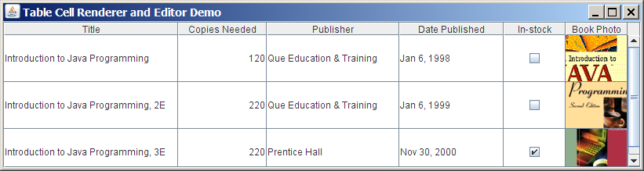

Figure 40.15
You need to use a custom table model to enable predefined renderers for Boolean and image cells.
Listing 40.7 gives a custom table model named MyTableModel that overrides the getColumnClass method (lines 15-17) to enable predefined renderers for Boolean and image cells. MyTableModel also overrides the isCellEditable() method (lines 20-24). By default, isCellEditable() returns true. The example does not allow the user to edit image icons and dates, so this method is overridden to return false to disable editing of date and image columns. For a cell to be editable, both isCellEditable() in the table model must be true.

Listing 40.7 MyTableModel.java
<margin note line 15: column class>
<margin note line 20: cell editable?>

import javax.swing.*;
import javax.swing.table.*;
import java.util.*;

public class MyTableModel extends DefaultTableModel {
public MyTableModel() {
}

/** Construct a table model with specified data and columnNames */
public MyTableModel(Object[][] data, Object[] columnNames) {
super(data, columnNames);
}

/** Override this method to return a class for the column */
public Class getColumnClass(int column) {
return getValueAt(0, column).getClass();
}

/** Override this method to return true if cell is editable */
public boolean isCellEditable(int row, int column) {

Class columnClass = getColumnClass(column);
return columnClass != ImageIcon.class &&
columnClass != Date.class;
}
}

If you create a JTable using a table model created from MyTableModel, the default renderers and editors for numbers, Boolean values, dates, and icons are used to display and edit these columns. Listing 40.8 gives a test program. The program creates a table model using MyTableModel (line 36). JTable assigns a predefined cell renderer and a predefined editor to the cell, whose class is specified in the getColumnClass() method in MyTableModel.

Listing 40.8 TableCellRendererEditorDemo.java
<margin note line 7: column names>
<margin note line 12: image icons>
<margin note line 20: row data>
<margin note line 36: table model>
<margin note line 40: table>
<margin note line 47: main method omitted>
import java.awt.*;
import javax.swing.*;
import java.util.*;

public class TableCellRendererEditorDemo extends JApplet {
// Create table column names
private String[] columnNames =
{"Title", "Copies Needed", "Publisher", "Date Published",

"In-stock", "Book Photo"};

// Create image icons
private ImageIcon intro1eImageIcon = new ImageIcon(
getClass().getResource("image/intro1e.gif"));
private ImageIcon intro2eImageIcon = new ImageIcon(
getClass().getResource("image/intro2e.gif"));
private ImageIcon intro3eImageIcon = new ImageIcon(
getClass().getResource("image/intro3e.jpg"));

// Create table data
private Object[][] rowData = {
{"Introduction to Java Programming", 120,

"Que Education & Training",
new GregorianCalendar(1998, 1-1, 6).getTime(),
false, intro1eImageIcon},
{"Introduction to Java Programming, 2E", 220,

"Que Education & Training",
new GregorianCalendar(1999, 1-1, 6).getTime(),
false, intro2eImageIcon},
{"Introduction to Java Programming, 3E", 220,

"Prentice Hall",
new GregorianCalendar(2000, 12-1, 0).getTime(),
true, intro3eImageIcon},
};

// Create a table model
private MyTableModel tableModel = new MyTableModel(
rowData, columnNames);

// Create a table
private JTable jTable1 = new JTable(tableModel);

public TableCellRendererEditorDemo() {
jTable1.setRowHeight(60);
add(new JScrollPane(jTable1), BorderLayout.CENTER);
}
}

The example defines two classes: MyTableModel and TableCellRendererEditorDemo. MyTableModel is an extension of DefaultTableModel. The purpose of MyTableModel is to override the default implementation of the getColumnClass() method to return the class of the column, so that an appropriate predefined JTable can be used for the column. By default, getColumnClass() returns Object.class.

40.7 Custom Table Renderers and Editors
Predefined renderers and editors are convenient and easy to use, but their functions are limited. The predefined image icon renderer displays the image icon in a label. The image icon cannot be scaled. If you want the whole image to fit in a cell, you need to create a custom renderer.

A custom renderer can be created by extending the DefaultTableCellRenderer, which is a default implementation for the TableCellRenderer interface. The custom renderer must override the getTableCellRendererComponent method to return a component for rendering the table cell. The getTableCellRendererComponent method is defined as follows:

public Component getTableCellRendererComponent
(JTable table, Object value, boolean isSelected,
boolean isFocused, int row, int column)
This method signature is very similar to the getListCellRendererComponent() method used to create custom list cell renderers.

This method is passed with a JTable, the value associated with the cell, information regarding whether the value is selected and whether the cell has the focus, and the row and column indices of the value. The component returned from the method is painted on the cell in the table. The class in Listing 40.9, MyImageCellRenderer, defines a renderer for displaying image icons in a panel.

Listing 40.9 MyImageCellRenderer.java
<margin note line 7: override method>
<margin note line 10: getImage()>
<margin note line 11: create image viewer>
<margin note line 13: return image viewer>

import javax.swing.*;
import javax.swing.table.*;
import java.awt.*;

public class MyImageCellRenderer extends DefaultTableCellRenderer {
/** Override this method in DefaultTableCellRenderer */
public Component getTableCellRendererComponent
(JTable table, Object value, boolean isSelected,
boolean isFocused, int row, int column) {

Image image = ((ImageIcon)value).getImage();
ImageViewer imageViewer = new ImageViewer(image);

return imageViewer;
}
}

You can also create a custom editor. JTable provides the DefaultCellEditor class, which can be used to edit a cell in a text field, a check box, or a combo box. To use it, simply create a text field, a check box, or a combo box, and pass it to DefaultCellEditor's constructor to create an editor.

Using a custom renderer and editor, the preceding example can be revised to display scaled images and to use a custom combo editor to edit the cells in the Publisher column, as shown in Figure 40.16. The program is given in Listing 40.10.

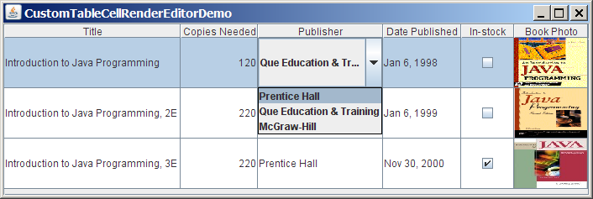

Figure 40.16
A custom renderer displays a scaled image, and a custom editor edits the Publisher column using a combo box.

Listing 40.10 CustomTableCellRendererEditorDemo.java
<margin note line 8: column names>
<margin note line 13: image icons>
<margin note line 21: row data>
<margin note line 37: table model>
<margin note line 41: table>
<margin note line 46: set renderer>
<margin note line 49: combo box>
<margin note line 56: set editor>
<margin note line 63: main method omitted>

import java.awt.*;
import javax.swing.*;
import javax.swing.table.*;
import java.util.*;

public class CustomTableCellRendererEditorDemo extends JApplet {
// Create table column names
private String[] columnNames =
{"Title", "Copies Needed", "Publisher", "Date Published",

"In-stock", "Book Photo"};

// Create image icons
private ImageIcon intro1eImageIcon =
new ImageIcon(getClass().getResource("image/intro1e.gif"));
private ImageIcon intro2eImageIcon =
new ImageIcon(getClass().getResource("image/intro2e.gif"));
private ImageIcon intro3eImageIcon =
new ImageIcon(getClass().getResource("image/intro3e.jpg"));

// Create table data
private Object[][] rowData = {
{"Introduction to Java Programming", 120,

"Que Education & Training",
new GregorianCalendar(1998, 1-1, 6).getTime(),
false, intro1eImageIcon},
{"Introduction to Java Programming, 2E", 220,

"Que Education & Training",
new GregorianCalendar(1999, 1-1, 6).getTime(),
false, intro2eImageIcon},
{"Introduction to Java Programming, 3E", 220,

"Prentice Hall",
new GregorianCalendar(2000, 12-1, 0).getTime(),
true, intro3eImageIcon},
};

// Create a table model
private MyTableModel tableModel = new MyTableModel(
rowData, columnNames);

// Create a table
private JTable jTable1 = new JTable(tableModel);

public CustomTableCellRendererEditorDemo() {
// Set custom renderer for displaying images

TableColumn bookCover = jTable1.getColumn("Book Photo");
bookCover.setCellRenderer(new MyImageCellRenderer());

// Create a combo box for publishers

JComboBox jcboPublishers = new JComboBox();
jcboPublishers.addItem("Prentice Hall");
jcboPublishers.addItem("Que Education & Training");
jcboPublishers.addItem("McGraw-Hill");

// Set combo box as the editor for the publisher column

TableColumn publisherColumn = jTable1.getColumn("Publisher");
publisherColumn.setCellEditor(
new DefaultCellEditor(jcboPublishers));

jTable1.setRowHeight(60);
add(new JScrollPane(jTable1),

BorderLayout.CENTER);
}
}

This example uses the same table model (MyTableModel) that was created in the preceding example (lines 37-38). By default, image icons are displayed using the predefined image icon renderer. To use MyImageCellRenderer to display the image, you have to explicitly specify the MyImageCellRenderer renderer for the Book Photo column (line 46). Likewise, you have to explicitly specify the combo box editor for the Publisher column (lines 56-57); otherwise the default editor would be used.

When you edit a cell in the Publisher column, a combo box of three items is displayed. When you select an item from the box, it is displayed in the cell. You did not write the code for handling selections. The selections are handled by the DefaultCellEditor class.

When you resize the Book Photo column, the image is resized to fit into the whole cell. With the predefined image renderer, you can see only part of the image if the cell is smaller than the image.

40.8 Table Model Events
JTable does not fire table events. It fires events like MouseEvent, KeyEvent, and ComponentEvent that are inherited from its superclass, JComponent. Table events are fired by table models, table column models, and table-selection models whenever changes are made to these models. Table models fire TableModelEvent when table data are changed. Table column models fire TableColumnModelEvent when columns are added, removed, or moved, or when a column is selected. Table-selection models fire ListSelectionEvent when a selection is made.

To listen for these events, a listener must be registered with an appropriate model and implement the correct listener interface. Listing 40.11 gives an example that demonstrates how to use these events. The program displays messages on a text area when a row or a column is selected, when a cell is edited, or when a column is removed. Figure 40.17 is a sample run of the program.

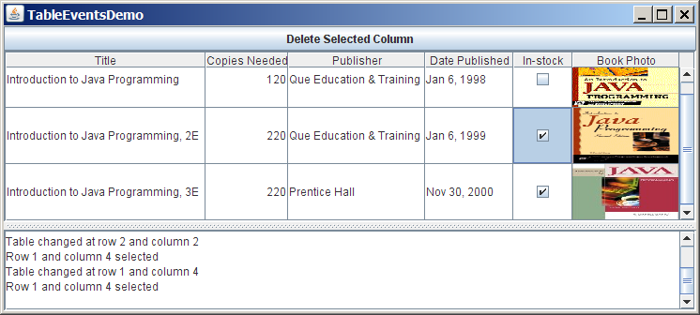

Figure 40.17
Table event handlers display table events on a text area.

Listing 40.11 TableEventsDemo.java
<margin note line 10: column names>
<margin note line 15: image icons>
<margin note line 23: table data>
<margin note line 39: table model>
<margin note line 43: table>
<margin note line 46: column model>
<margin note line 50: selection model>
<margin note line 86: table model listener>
<margin note line 94: column model listener>
<margin note line 131: selection model listener>
<margin note line 141: main method omitted>

1 import java.awt.*;
2 import java.awt.event.*;
3 import javax.swing.*;
4 import javax.swing.event.*;
5 import javax.swing.table.*;
6 import java.util.*;
7
8 public class TableEventsDemo extends JApplet {
9 // Create table column names
10 private String[] columnNames =
11 {"Title", "Copies Needed", "Publisher", "Date Published",
12 "In-stock", "Book Photo"};
13
14 // Create image icons
15 private ImageIcon intro1eImageIcon =
16 new ImageIcon(getClass().getResource("/image/intro1e.gif"));
17 private ImageIcon intro2eImageIcon =
18 new ImageIcon(getClass().getResource("/image/intro2e.gif"));
19 private ImageIcon intro3eImageIcon =
20 new ImageIcon(getClass().getResource("/image/intro3e.jpg"));
21
22 // Create table data
23 private Object[][] rowData = {
24 {"Introduction to Java Programming", 120,
25 "Que Education & Training",
26 new GregorianCalendar(1998, 1-1, 6).getTime(),
27 false, intro1eImageIcon},
28 {"Introduction to Java Programming, 2E", 220,
29 "Que Education & Training",
30 new GregorianCalendar(1999, 1-1, 6).getTime(),
31 false, intro2eImageIcon},
32 {"Introduction to Java Programming, 3E", 220,
33 "Prentice Hall",
34 new GregorianCalendar(2000, 12-1, 0).getTime(),
35 true, intro3eImageIcon},
36 };
37
38 // Create a table model
39 private MyTableModel tableModel = new MyTableModel(
40 rowData, columnNames);
41
42 // Create a table
43 private JTable jTable1 = new JTable(tableModel);
44
45 // Get table column model
46 private TableColumnModel tableColumnModel =
47 jTable1.getColumnModel();
48
49 // Get table selection model
50 private ListSelectionModel selectionModel =
51 jTable1.getSelectionModel();
52
53 // Create a text area
54 private JTextArea jtaMessage = new JTextArea();
55
56 // Create a button
57 private JButton jbtDeleteColumn =
58 new JButton("Delete Selected Column");
59
60 public TableEventsDemo() {
61 // Set custom renderer for displaying images
62 TableColumn bookCover = jTable1.getColumn("Book Photo");
63 bookCover.setCellRenderer(new MyImageCellRenderer());
64
65 // Create a combo box for publishers
66 JComboBox jcboPublishers = new JComboBox();
67 jcboPublishers.addItem("Prentice Hall");
68 jcboPublishers.addItem("Que Education & Training");
69 jcboPublishers.addItem("McGraw-Hill");
70
71 // Set combo box as the editor for the publisher column
72 TableColumn publisherColumn = jTable1.getColumn("Publisher");
73 publisherColumn.setCellEditor(
74 new DefaultCellEditor(jcboPublishers));
75
76 jTable1.setRowHeight(60);
77 jTable1.setColumnSelectionAllowed(true);
78
79 JSplitPane jSplitPane1 = new JSplitPane(
80 JSplitPane.VERTICAL_SPLIT);
81 jSplitPane1.add(new JScrollPane(jTable1), JSplitPane.LEFT);
82 jSplitPane1.add(new JScrollPane(jtaMessage), JSplitPane.RIGHT);
83 add(jbtDeleteColumn, BorderLayout.NORTH);
84 add(jSplitPane1, BorderLayout.CENTER);
85
86 tableModel.addTableModelListener(new TableModelListener() {
87 @Override
88 public void tableChanged(TableModelEvent e) {
89 jtaMessage.append("Table changed at row " +
90 e.getFirstRow() + " and column " + e.getColumn() + "\n");
91 }
92 });
93
94 tableColumnModel.addColumnModelListener(
95 new TableColumnModelListener() {
96 @Override
97 public void columnRemoved(TableColumnModelEvent e) {
98 jtaMessage.append("Column indexed at " + e.getFromIndex() +
99 " is deleted \n");
100 }
101
102 @Override
103 public void columnAdded(TableColumnModelEvent e) {
104 }
105
106 @Override
107 public void columnMoved(TableColumnModelEvent e) {
108 }
109
110 @Override
111 public void columnMarginChanged(ChangeEvent e) {
112 }
113
114 @Override
115 public void columnSelectionChanged(ListSelectionEvent e) {
116 }
117 });
118
119 jbtDeleteColumn.addActionListener(new ActionListener() {
120 @Override
121 public void actionPerformed(ActionEvent e) {
122 if (jTable1.getSelectedColumn() >= 0) {
123 TableColumnModel columnModel = jTable1.getColumnModel();
124 TableColumn tableColumn =
125 columnModel.getColumn(jTable1.getSelectedColumn());
126 columnModel.removeColumn(tableColumn);
127 }
128 }
129 });
130
131 selectionModel.addListSelectionListener(
132 new ListSelectionListener() {
133 @Override
134 public void valueChanged(ListSelectionEvent e) {
135 jtaMessage.append("Row " + jTable1.getSelectedRow() +
136 " and column " + jTable1.getSelectedColumn() +
137 " selected\n");
138 }
139 });
140 }
141 }

To respond to the row and column selection events, you need to implement the valueChanged method in ListSelectionListener. To respond to the cell-editing event, you need to implement the tableChanged method in TableModelListener. To respond to the column-deletion event, you need to implement the columnRemoved method in TableColumnModelListener. Let’s use the same table from the preceding example, but with a button added for deleting the selected column and a text area for displaying the messages.

A table model is created using MyTableModel (lines 39-40), which was given in Listing 40.7. When a table is created (line 43), its default column model and selection model are also created. Therefore, you can obtain the table column model and selection model from the table (lines 46-51).

When a row or a column is selected, a ListSelectionEvent is fired by selectionModel, which invokes the handler to display the selected row and column in the text area (lines 134-138). When the content or structure of the table is changed, a TableModelEvent is fired by tableModel, which invokes the handler to display the last row and last column of the changed data in the text area (lines 88-91). When a column is deleted by clicking the Delete Selected Column button, a ColumnModelEvent is fired by tableColumnModel, which invokes the handler to display the index of the deleted column (lines 97-100).

40.9 JTree
JTree is a Swing component that displays data in a treelike hierarchy, as shown in Figure 40.18.

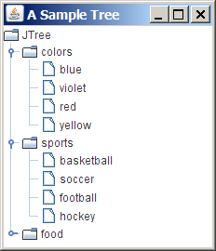

Figure 40.18
JTree displays data in a treelike hierarchy.
All the nodes displayed in the tree are in the form of a hierarchical indexed list. The tree can be used to navigate structured data with hierarchical relationships. A node can have child nodes. A node is called a leaf if it has no children; a node with no parent is called the root of its tree. A tree may consist of many subtrees, each node acting as the root for its own subtree.

A nonleaf node can be expanded or collapsed by double-clicking on the node or on the node's handle in front of the node. The handle usually has a visible sign to indicate whether the node is expanded or collapsed. For example, on Windows, the + symbol indicates that the node can be expanded, and the – symbol, that it can be collapsed.

Like JTable, JTree is a very complex component with many supporting interfaces and classes. JTree is in the javax.swing package, but its supporting interfaces and classes are all included in the javax.swing.tree package. The supporting interfaces are TreeModel, TreeSelectionModel, TreeNode, and MutableTreeNode, and the supporting classes are DefaultTreeModel, DefaultMutableTreeNode, DefaultTreeCellEditor, DefaultTreeCellRenderer, and TreePath.

While JTree displays the tree, the data representation of the tree is handled by TreeModel, TreeNode, and TreePath. TreeModel represents the entire tree, TreeNode represents a node, and TreePath represents a path to a node. Unlike the ListModel or TableModel, TreeModel does not directly store or manage tree data. Tree data are stored and managed in TreeNode and TreePath. DefaultTreeModel is a concrete implementation of TreeModel. MutableTreeNode is a subinterface of TreeNode, which represents a tree node that can be mutated by adding or removing child nodes, or by changing the contents of a user object stored in the node.

The TreeSelectionModel interface handles tree node selection. The DefaultTreeCellRenderer class provides a default tree node renderer that can display a label and/or an icon in a node. The DefaultTreeCellEditor can be used to edit the cells in a text field.

A TreePath is an array of Objects that are vended from a TreeModel. The elements of the array are ordered such that the root is always the first element (index 0) of the array. Figure 40.19 shows how these interfaces and classes are interrelated.

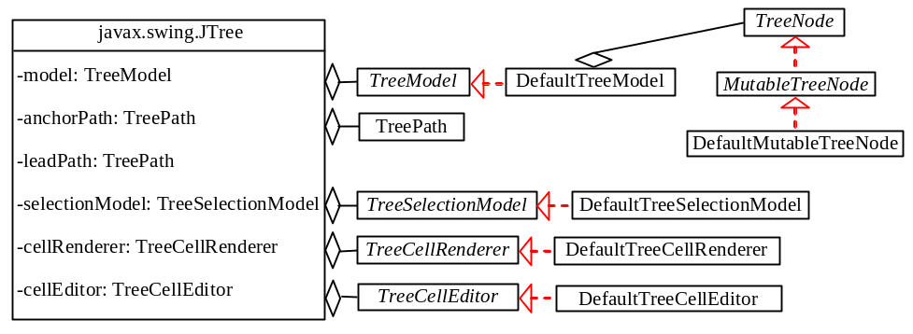

Figure 40.19
JTree contains many supporting interfaces and classes.
Figure 40.20 shows the constructors, frequently used properties, and methods of JTree.

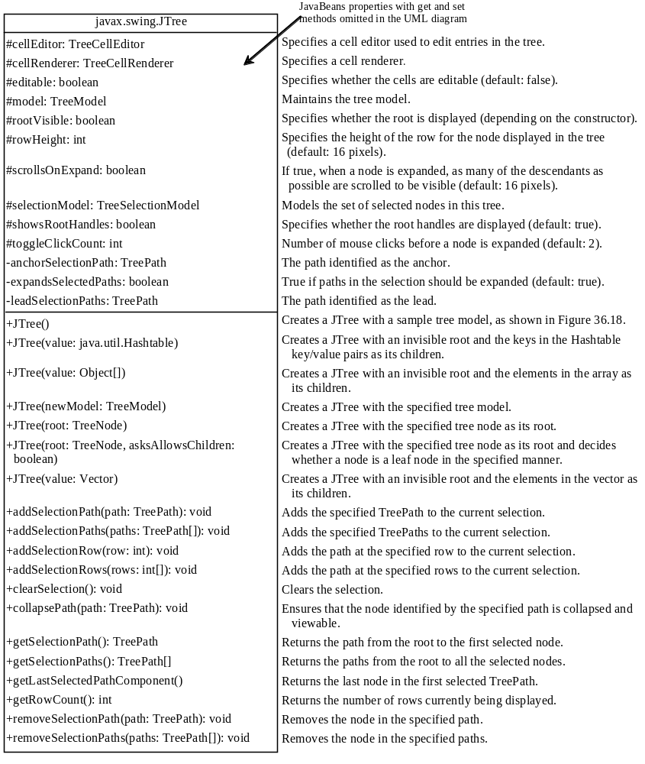

Figure 40.20
The JTree class is for creating, customizing, and manipulating trees.
The JTree class contains seven constructors for creating trees. You can create a tree using its no-arg constructor, a tree model, a tree node, a Hashtable, an array, or a vector. Using the no-arg constructor, a sample tree is created as shown in Figure 40.18. Using a Hashtable, an array, or a vector, a root is created but not displayed. All the keys in a Hashtable, all the objects in an array, and all the elements in a vector are added into the tree as children of the root. If you wish the root to be displayed, set the rootVisible property to true.

All the methods related to path selection are also defined in the TreeSelectionModel interface, which will be covered in §40.12, “TreePath and TreeSelectionModel.”

Listing 40.12 gives an example that creates four trees: a default tree using the no-arg constructor, a tree created from an array of objects, a tree created from a vector, and a tree created from a hash table, as shown in Figure 40.21. Enable the user to dynamically set the properties for rootVisible, rowHeight, and showsRootHandles.

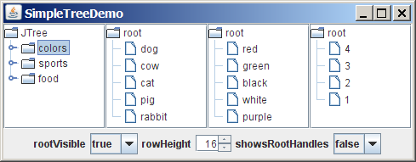

Figure 40.21
You can dynamically set the properties for rootVisible, rowHeight, and showRootHandles in a tree.

Listing 40.12 SimpleTreeDemo.java
<margin note line 9: tree 1>
<margin note line 12: tree 2>
<margin note line 16: tree 3>
<margin note line 22: tree 4>
<margin note line 43: tree>
<margin note line 63: combo box listener>
<margin note line 86: spinner listener>
<margin note line 97: main method omitted>

1 import java.awt.*;
2 import java.awt.event.*;
3 import javax.swing.*;
4 import javax.swing.event.*;
5 import java.util.*;
6
7 public class SimpleTreeDemo extends JApplet {
8 // Create a default tree
9 private JTree jTree1 = new JTree();
10
11 // Create a tree with an array of Objects.
12 private JTree jTree2 = new JTree(new String[]
13 {"dog", "cow", "cat", "pig", "rabbit"});
14
15 // Create a tree with a Hashtable
16 private Vector<Object> vector = new Vector<Object>(Arrays.asList(
17 new Object[]{"red", "green", "black", "white", "purple"}));
18 private JTree jTree3 = new JTree(vector);
19
20 private Hashtable<Integer, String> hashtable =
21 new Hashtable<Integer, String>();
22 private JTree jTree4;
23
24 // Create a combo box for selecting rootVisible
25 private JComboBox jcboRootVisible = new JComboBox(
26 new String[]{"false", "true"});
27
28 // Create a combo box for selecting showRootHandles
29 private JComboBox jcboShowsRootHandles = new JComboBox(
30 new String[] {"false", "true"});
31
32 // Create a spinner for selecting row height
33 private JSpinner jSpinnerRowHeight = new JSpinner(
34 new SpinnerNumberModel(16, 1, 50, 1));
35
36 public SimpleTreeDemo() {
37 jTree1.setRootVisible(false);
38
39 hashtable.put(1, "red");
40 hashtable.put(2, "green");
41 hashtable.put(3, "blue");
42 hashtable.put(4, "yellow");
43 jTree4 = new JTree(hashtable);
44
45 JPanel panel1 = new JPanel(new GridLayout(1, 4));
46 panel1.add(new JScrollPane(jTree1));
47 panel1.add(new JScrollPane(jTree2));
48 panel1.add(new JScrollPane(jTree3));
49 panel1.add(new JScrollPane(jTree4));
50
51 JPanel panel2 = new JPanel();
52 panel2.add(new JLabel("rootVisible"));
53 panel2.add(jcboRootVisible);
54 panel2.add(new JLabel("rowHeight"));
55 panel2.add(jSpinnerRowHeight);
56 panel2.add(new JLabel("showsRootHandles"));
57 panel2.add(jcboShowsRootHandles);
58
59 add(panel1, BorderLayout.CENTER);
60 add(panel2, BorderLayout.SOUTH);
61
62 // Register listeners
63 jcboRootVisible.addActionListener(new ActionListener() {
64 public void actionPerformed(ActionEvent e) {
65 boolean rootVisible =
66 jcboRootVisible.getSelectedItem().equals("true");
67 jTree1.setRootVisible(rootVisible);
68 jTree2.setRootVisible(rootVisible);
69 jTree3.setRootVisible(rootVisible);
70 jTree4.setRootVisible(rootVisible);
71 }
72 });
73
74 jcboShowsRootHandles.addActionListener(new ActionListener() {
75 @Override
76 public void actionPerformed(ActionEvent e) {
77 boolean showsRootHandles =
78 jcboShowsRootHandles.getSelectedItem().equals("true");
79 jTree1.setShowsRootHandles(showsRootHandles);
80 jTree2.setShowsRootHandles(showsRootHandles);
81 jTree3.setShowsRootHandles(showsRootHandles);
82 jTree4.setShowsRootHandles(showsRootHandles);
83 }
84 });
85
86 jSpinnerRowHeight.addChangeListener(new ChangeListener() {
87 public void stateChanged(ChangeEvent e) {
88 int height =
89 ((Integer)(jSpinnerRowHeight.getValue())).intValue();
90 jTree1.setRowHeight(height);
91 jTree2.setRowHeight(height);
92 jTree3.setRowHeight(height);
93 jTree4.setRowHeight(height);
94 }
95 });
96 }
97 }

Four trees are created in this example. The first is created using the no-arg constructor (line 9) with a default sample tree. The second is created using an array of objects (lines 12-13). All the objects in the array become the children of the root. The third is created using a vector (lines 16-18). All the elements in the vector become the children of the root. The fourth is created using a hash table (lines 39-43). A Hashtable is like a Map. Hashtable was introduced earlier than Java 2 and has since been replaced by Map. It is used in the Java API (e.g., JTree), which was developed before Java 2. The keys of the hash table become the children of the root.

JTree doesn't directly support scrolling. To create a scrollable tree, create a JScrollPane and add an instance of JTree to the scroll pane (lines 46-49).

The example enables you to specify whether the root is visible and whether the root handles are visible from two combo boxes (lines 63-83). It also lets you specify the row height of the node in a spinner (lines 85-94).

40.10 TreeModel and DefaultTreeModel
The TreeModel interface represents the entire tree. Unlike ListModel or TableModel, TreeModel does not directly store or manage tree data. TreeModel contains the structural information about the tree, and tree data are stored and managed by TreeNode.

DefaultTreeModel is a concrete implementation for TreeModel that uses TreeNodes. Figure 40.22 shows TreeModel and DefaultTreeModel.

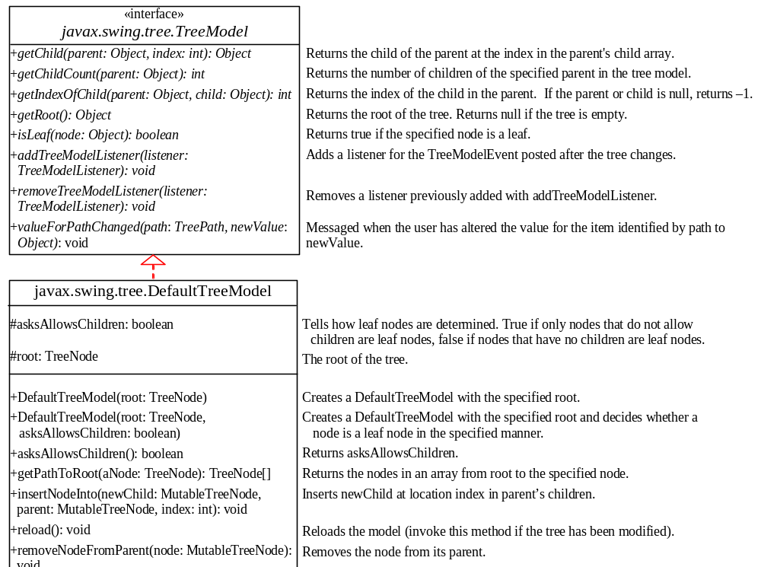

Figure 40.22
TreeModel represents an entire tree and DefaultTreeModel is a concrete implementation of it.

Once a tree is created, you can obtain its tree model using the getModel method. Listing 40.13 gives an example that traverses all the nodes in a tree using the tree model. Line 1 creates a tree using JTree’s no-arg constructor with the default sample nodes, as shown in Figure 40.18. The tree model for the tree is obtained in line 4. Line 5 invokes the traversal method to traverse the nodes in the tree.

Listing 40.13 TestTreeModel.java
<margin note line 3: default tree>
<margin note line 4: tree model>
<margin note line 5: getRoot>
<margin note line 11: is leaf?>
<margin note line 12: getChildCount>
<margin note line 13: getChild>

1 public class TestTreeModel {
2 public static void main(String[] args) {
3 javax.swing.JTree jTree1 = new javax.swing.JTree();
4 javax.swing.tree.TreeModel model = jTree1.getModel();
5 traversal(model, model.getRoot());
6 }
7
8 private static void traversal
9 (javax.swing.tree.TreeModel model, Object root) {
10 System.out.print(root + " ");
11 if (model.isLeaf(root)) return;
12 for (int i = 0; i < model.getChildCount(root); i++) {
13 traversal(model, model.getChild(root, i));
14 }
15 }
16 }

<Output>

JTree colors blue violet red yellow sports basketball soccer

football hockey food hot dogs pizza ravioli bananas
<End Output>

The traversal method starts from the root of the tree. The root is obtained by invoking the getRoot method (line 5). If the root is a leaf, the method returns (line 11). Otherwise, it recursively invokes the traversal method to start from the children of the root (line 13).

40.11 TreeNode, MutableTreeNode, and DefaultMutableTreeNode
While TreeModel represents the entire tree, TreeNode stores a single node of the tree. MutableTreeNode defines a subinterface of TreeNode with additional methods for changing the content of the node, for inserting and removing a child node, for setting a new parent, and for removing the node itself.

DefaultMutableTreeNode is a concrete implementation of MutableTreeNode that maintains a list of children in a vector and provides the operations for creating nodes, for examining and modifying a node's parent and children, and also for examining the tree to which the node belongs. Normally, you should use DefaultMutableTreeNode to create a tree node. Figure 40.23 shows TreeNode, MutableTreeNode, and DefaultMutableTreeNode.

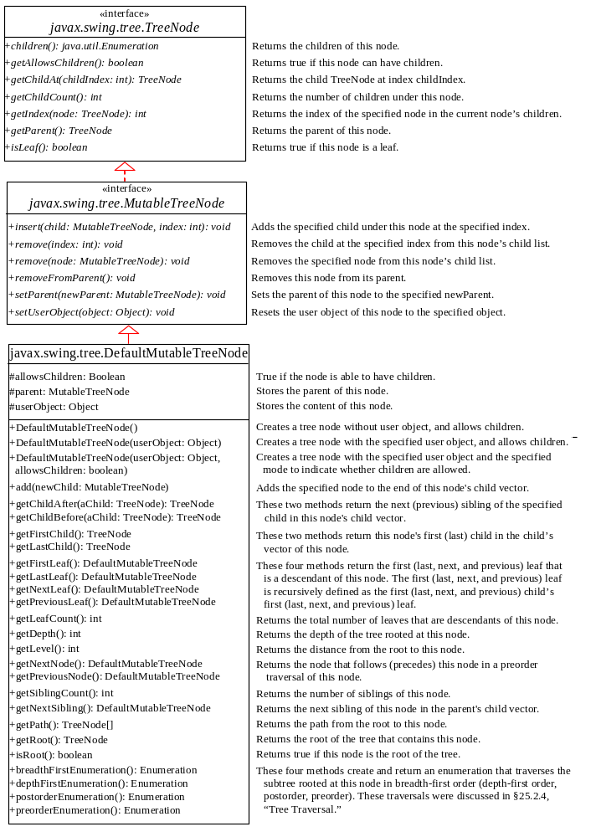

Figure 40.23
TreeNode represents a node.

NOTE
<margin note: depth-first traversal>
In graph theory, depth-first traversal is defined the same as preorder traversal, but in the depthFirstEnumeration() method in DefaultMutableTreeNode, it is the same as postorder traversal.

NOTE
<margin note: creating trees>
You can create a JTree from a root using new JTree(TreeNode) or from a model using new JTree(TreeModel). To create a tree model, you first create an instance of TreeNode to represent the root of the tree, and then create an instance of DefaultTreeModel fitted with the root.
Listing 40.14 gives an example that creates two trees to display world, continents, countries, and states. The two trees share the same nodes and thus display identical contents. The program also displays the properties of the tree in a text area, as shown in Figure 40.24.

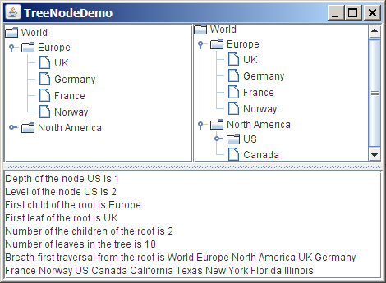

Figure 40.24
The two trees have the same data because their roots are the same.

Listing 40.14 TreeNodeDemo.java
<margin note line 9: tree nodes>
<margin note line 12: add children>
<margin note line 19: add children>
<margin note line 62: main method omitted>

1 import java.awt.*;
2 import javax.swing.*;
3 import javax.swing.tree.*;
4 import java.util.*;
5
6 public class TreeNodeDemo extends JApplet {
7 public TreeNodeDemo() {
8 // Create the first tree
9 DefaultMutableTreeNode root, europe, northAmerica, us;
10
11 europe = new DefaultMutableTreeNode("Europe");
12 europe.add(new DefaultMutableTreeNode("UK"));
13 europe.add(new DefaultMutableTreeNode("Germany"));
14 europe.add(new DefaultMutableTreeNode("France"));
15 europe.add(new DefaultMutableTreeNode("Norway"));
16
17 northAmerica = new DefaultMutableTreeNode("North America");
18 us = new DefaultMutableTreeNode("US");
19 us.add(new DefaultMutableTreeNode("California"));
20 us.add(new DefaultMutableTreeNode("Texas"));
21 us.add(new DefaultMutableTreeNode("New York"));
22 us.add(new DefaultMutableTreeNode("Florida"));
23 us.add(new DefaultMutableTreeNode("Illinois"));
24 northAmerica.add(us);
25 northAmerica.add(new DefaultMutableTreeNode("Canada"));
26
27 root = new DefaultMutableTreeNode("World");
28 root.add(europe);
29 root.add(northAmerica);
30
31 JPanel panel = new JPanel();
32 panel.setLayout(new GridLayout(1, 2));
33 panel.add(new JScrollPane(new JTree(root)));
34 panel.add(new JScrollPane(new JTree(new DefaultTreeModel(root))));
35
36 JTextArea jtaMessage = new JTextArea();
37 jtaMessage.setWrapStyleWord(true);
38 jtaMessage.setLineWrap(true);
39 add(new JSplitPane(JSplitPane.VERTICAL_SPLIT,
40 panel, new JScrollPane(jtaMessage)), BorderLayout.CENTER);
41
42 // Get tree information
43 jtaMessage.append("Depth of the node US is " + us.getDepth());
44 jtaMessage.append("\nLevel of the node US is " + us.getLevel());
45 jtaMessage.append("\nFirst child of the root is " +
46 root.getFirstChild());
47 jtaMessage.append("\nFirst leaf of the root is " +
48 root.getFirstLeaf());
49 jtaMessage.append("\nNumber of the children of the root is " +
50 root.getChildCount());
51 jtaMessage.append("\nNumber of leaves in the tree is " +
52 root.getLeafCount());
53 String breadthFirstSearchResult = "";
54
55 // Breadth-first traversal
56 Enumeration bf = root.breadthFirstEnumeration();
57 while (bf.hasMoreElements())
58 breadthFirstSearchResult += bf.nextElement().toString() + " ";
59 jtaMessage.append("\nBreath-first traversal from the root is "
60 + breadthFirstSearchResult);
61 }
62 }

You can create a JTree using a TreeNode root (line 33) or a TreeModel (line 34), whichever is convenient. A TreeModel is actually created using a TreeNode root (line 34). The two trees have the same contents because the root is the same. However, it is important to note that the two JTree objects are different, and so are their TreeModel objects, although both trees have the same root.

A tree is created by adding the nodes to the tree (lines 9-29). Each node is created using the DefaultMutableTreeNode class. This class provides many methods to manipulate the tree (e.g., adding a child, removing a child) and obtaining information about the tree (e.g., level, depth, number of children, number of leaves, traversals). Some examples of using these methods are given in lines 43-60.

As shown in this example, often you don’t have to directly use TreeModel. Using DefaultMutableTreeNode is sufficient, since the tree data are stored in DefaultMutableTreeNode, and DefaultMutableTreeNode contains all the methods for modifying the tree and obtaining tree information.

40.12 TreePath and TreeSelectionModel
The JTree class contains the methods for selecting tree paths. The TreePath class represents a path from an ancestor to a descendant in a tree. Figure 40.25 shows TreePath.

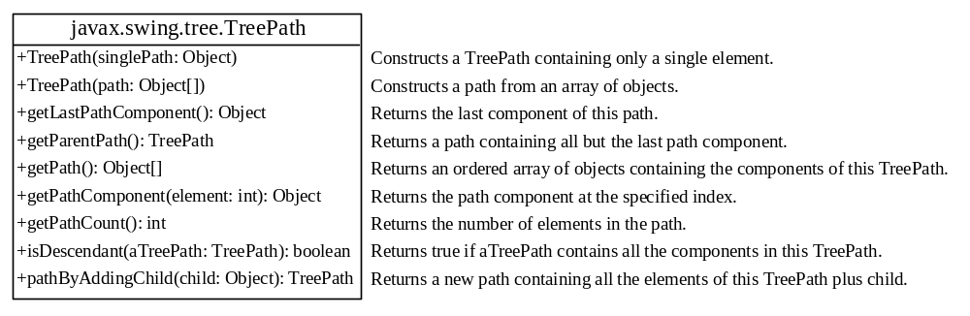

Figure 40.25
TreePath represents a path from an ancestor to a descendant in a tree.
<margin note: obtain tree paths>
You can construct a TreePath from a single object or an array of objects, but often instances of TreePath are returned from the methods in JTree and TreeSelectionModel. For instance, the getLeadSelectionPath() method in JTree returns the path from the root to the selected node. There are many ways to extract the nodes from a tree path. Often you use the getLastPathComponent() method to obtain the last node in the path, and then the getParent() method to get all the nodes in the path upward through the link.

The selection of tree nodes is defined in the TreeSelectionModel interface, as shown in Figure 40.26. The DefaultTreeSelectionModel class is a concrete implementation of the TreeSelectionModel that maintains an array of TreePath objects representing the current selection. The last TreePath selected, called the lead path, can be obtained using the getLeadSelectionPath() method. To obtain all the selection paths, use the getSelectionPaths() method, which returns an array of tree paths.

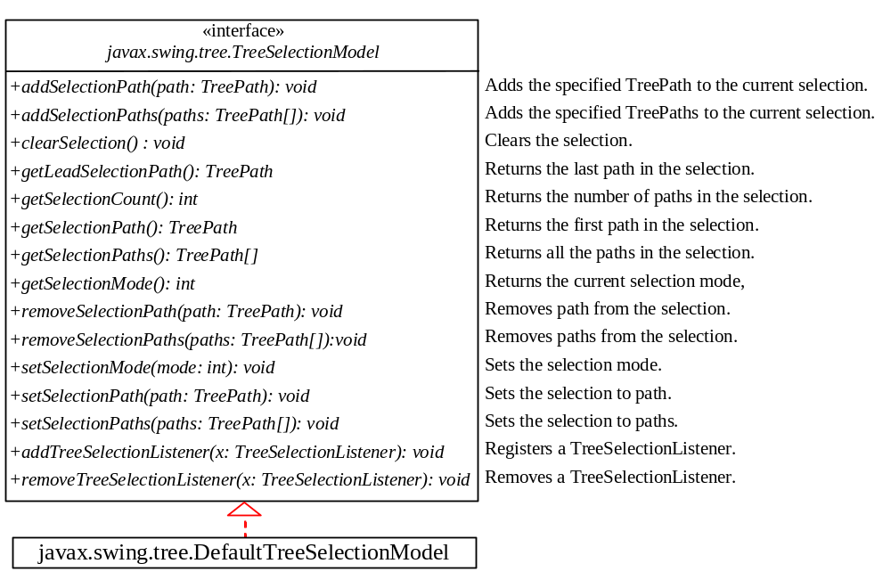

Figure 40.26
The TreeSelectionModel handles selection in a tree and DefaultTreeSelectionModel is a concrete implementation of it.
<margin note: tree selection modes>
TreeSelectionModel supports three selection modes: contiguous selection, discontiguous selection, and single selection. Single selection allows only one item to be selected. Contiguous selection allows multiple selections, but the selected items must be contiguous. Discontigous selection is the most flexible; it allows any item to be selected at a given time. The default tree selection mode is discontiguous. To set a selection mode, use the setSelectionMode(int mode) method in TreeSelectionModel. The constants for the three modes are:

- CONTIGUOUS_TREE_SELECTION
- DISCONTIGUOUS_TREE_SELECTION
- SINGLE_TREE_SELECTION

NOTE
<margin note: bypass TreeSelectionModel>
When you create a JTree, a DefaultTreeSelectionModel is automatically created, and thus you rarely need to create an instance of TreeSelectionModel explicitly. Since most of the methods in TreeSelectionModel are also in JTree, you can get selection paths and process the selection without directly dealing with TreeSelectionModel.
Listing 40.15 gives an example that displays a selected path or selected paths in tree. The user may select a node or multiple nodes and click the Show Path button to display the properties of the first selected path or the Show Paths button to display all the selected paths in a text area, as shown in Figure 40.27. The Show Path button displays a path from the last node up to the root.

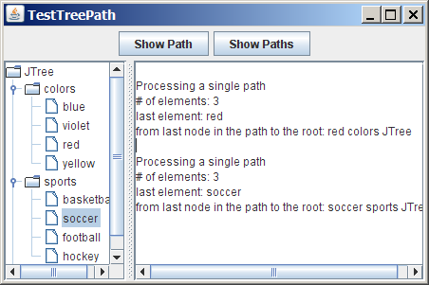

Figure 40.27

The selected path(s) are processed.

Listing 40.15 TestTreePath.java
<margin note line 7: default tree>
<margin note line 8: text area>
<margin note line 9: Show Path button>
<margin note line 10: Show Paths button>
<margin note line 13: split pane>
<margin note line 23: Show Path button>
<margin note line 26: selected path>
<margin note line 28: path count>
<margin note line 32: last node>
<margin note line 35: get parent>
<margin note line 39: Show Paths button>
<margin note line 43: selected paths>
<margin note line 44: display a path>
<margin note line 48: main method omitted>

1 import java.awt.*;
2 import java.awt.event.*;
3 import javax.swing.*;
4 import javax.swing.tree.*;
5
6 public class TestTreePath extends JApplet {
7 private JTree jTree = new JTree();
8 private JTextArea jtaOutput = new JTextArea();
9 private JButton jbtShowPath = new JButton("Show Path");
10 private JButton jbtShowPaths = new JButton("Show Paths");
11
12 public TestTreePath() {
13 JSplitPane splitPane = new JSplitPane(JSplitPane.HORIZONTAL_SPLIT,
14 new JScrollPane(jTree), new JScrollPane(jtaOutput));
15
16 JPanel panel = new JPanel();
17 panel.add(jbtShowPath);
18 panel.add(jbtShowPaths);
19
20 add(splitPane, BorderLayout.CENTER);
21 add(panel, BorderLayout.NORTH);
22
23 jbtShowPath.addActionListener(new ActionListener() {
24 @Override
25 public void actionPerformed(ActionEvent e) {
26 TreePath path = jTree.getSelectionPath();
27 jtaOutput.append("\nProcessing a single path\n");
28 jtaOutput.append("# of elements: " + path.getPathCount());
29 jtaOutput.append("\nlast element: "
30 + path.getLastPathComponent());
31 jtaOutput.append("\nfrom last node in the path to the root: ");
32 TreeNode node = (TreeNode)path.getLastPathComponent();
33 while (node != null) {
34 jtaOutput.append(node.toString() + " ");
35 node = node.getParent();
36 }
37 }});
38
39 jbtShowPaths.addActionListener(new ActionListener() {
40 @Override
41 public void actionPerformed(ActionEvent e) {
42 jtaOutput.append("\nProcessing multiple paths\n");
43 javax.swing.tree.TreePath[] paths = jTree.getSelectionPaths();
44 for (int i = 0; i < paths.length; i++)
45 jtaOutput.append(paths[i].toString() + "\n");
46 }});
47 }
48 }

The getSelectionPath() method invoked from a JTree returns a TreePath in line 25. The first node in the path is always the root of the tree. The getPathCount() invoked from a TreePath returns the number of the nodes in the path (line 27). The getLastPathComponent() invoked from a TreePath returns the last node in the path (line 29). The return node type is Object. You need to cast it to a TreeNode (line 31) in order to invoke the getParent() method from a TreeNode (line 34).

While the getSelectionPath() method (line 25) returns the first selected path, the getSelectionPaths() method (line 41) returns all the selected paths in an array of paths.

40.13 Case Study: Modifying Trees
Write a program to create two trees that display the same contents: world, continents, countries, and states, as shown in Figure 40.28. For the tree on the left, enable the user to choose a selection mode, specify whether it can be edited, add a new child under the first selected node, and remove all the selected nodes.

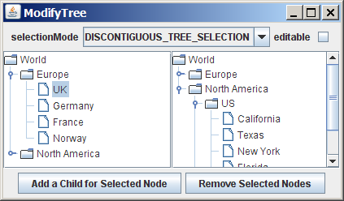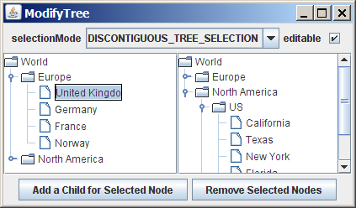
(a) (b)

Figure 40.28
You can rename a node, add a child, and remove nodes in a tree dynamically.
You can choose a selection mode from the selectionMode combo box. You can specify whether the left tree nodes can be edited from the editable check box.

When you click a button, if no nodes are currently selected in the left tree, a message dialog box is displayed, as shown in Figure 40.29a. When you click the Add a Child for Selected Node button, an input dialog box is displayed to prompt the user to enter a child name for the selected node, as shown in Figure 40.29b. The new node becomes a child of the first selected node. When you click the Remove Selected Nodes button, all the selected nodes in the left tree are removed.

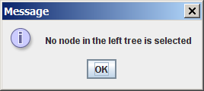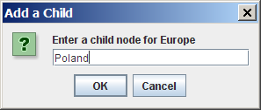
(a) (b)

Figure 40.29
You can add a new node to the tree.
Listing 40.16 gives the program.

Listing 40.16 ModifyTree.java
<margin note line 8: combo box>
<margin note line 13: check box>
<margin note line 16: buttons>
<margin note line 21: trees>
<margin note line 25: tree nodes>
<margin note line 27: fill nodes>
<margin note line 56: create jTree1>
<margin note line 57: create jTree2>
<margin note line 69: choose selection mode>
<margin note line 74: set selection mode>
<margin note line 86: choose editable>
<margin note line 89: set editable>
<margin note line 93: add child>
<margin note line 96: get selected node>
<margin note line 111: add new node>
<margin note line 114: reload tree model>
<margin note line 119: remove node>
<margin note line 122: get selected paths>
<margin note line 140: remove node>
<margin note line 144: reload tree model>
<margin note line 149: main method omitted>

1 import java.awt.*;
2 import java.awt.event.*;
3 import javax.swing.*;
4 import javax.swing.tree.*;
5
6 public class ModifyTree extends JApplet {
7 // Create a combo box for choosing selection modes
8 private JComboBox jcboSelectionMode = new JComboBox(new String[]{
9 "CONTIGUOUS_TREE_SELECTION", "DISCONTIGUOUS_TREE_SELECTION",
10 "SINGLE_TREE_SELECTION"});
11
12 // Create a check box for specifying editable
13 private JCheckBox jchkEditable = new JCheckBox();
14
15 // Create two buttons
16 private JButton jbtAdd =
17 new JButton("Add a Child for Selected Node");
18 private JButton jbtRemove = new JButton("Remove Selected Nodes");
19
20 // Declare two trees
21 private JTree jTree1, jTree2;
22
23 public ModifyTree() {
24 // Create the first tree
25 DefaultMutableTreeNode root, europe, northAmerica, us;
26
27 europe = new DefaultMutableTreeNode("Europe");
28 europe.add(new DefaultMutableTreeNode("UK"));
29 europe.add(new DefaultMutableTreeNode("Germany"));
30 europe.add(new DefaultMutableTreeNode("France"));
31 europe.add(new DefaultMutableTreeNode("Norway"));
32
33 northAmerica = new DefaultMutableTreeNode("North America");
34 us = new DefaultMutableTreeNode("US");
35 us.add(new DefaultMutableTreeNode("California"));
36 us.add(new DefaultMutableTreeNode("Texas"));
37 us.add(new DefaultMutableTreeNode("New York"));
38 us.add(new DefaultMutableTreeNode("Florida"));
39 us.add(new DefaultMutableTreeNode("Illinois"));
40 northAmerica.add(us);
41 northAmerica.add(new DefaultMutableTreeNode("Canada"));
42
43 root = new DefaultMutableTreeNode("World");
44 root.add(europe);
45 root.add(northAmerica);
46
47 jcboSelectionMode.setSelectedIndex(1);
48
49 JPanel p1 = new JPanel();
50 p1.add(new JLabel("selectionMode"));
51 p1.add(jcboSelectionMode);
52 p1.add(new JLabel("editable"));
53 p1.add(jchkEditable);
54
55 JPanel p2 = new JPanel(new GridLayout(1, 2));
56 p2.add(new JScrollPane(jTree1 = new JTree(root)));
57 p2.add(new JScrollPane(jTree2 =
58 new JTree(new DefaultTreeModel(root)))); // Same root as jTree1
59
60 JPanel p3 = new JPanel();
61 p3.add(jbtAdd);
62 p3.add(jbtRemove);
63
64 add(p1, BorderLayout.NORTH);
65 add(p2, BorderLayout.CENTER);
66 add(p3, BorderLayout.SOUTH);
67
68 // Register listeners
69 jcboSelectionMode.addActionListener(new ActionListener() {
70 @Override
71 public void actionPerformed(ActionEvent e) {
72 if (jcboSelectionMode.getSelectedItem().
73 equals("CONTIGUOUS_TREE_SELECTION"))
74 jTree1.getSelectionModel().setSelectionMode(
75 TreeSelectionModel.CONTIGUOUS_TREE_SELECTION);
76 else if (jcboSelectionMode.getSelectedItem().
77 equals("DISCONTIGUOUS_TREE_SELECTION"))
78 jTree1.getSelectionModel().setSelectionMode(
79 TreeSelectionModel.DISCONTIGUOUS_TREE_SELECTION);
80 else
81 jTree1.getSelectionModel().setSelectionMode(
82 TreeSelectionModel.SINGLE_TREE_SELECTION);
83 }
84 });
85
86 jchkEditable.addActionListener(new ActionListener() {
87 @Override
88 public void actionPerformed(ActionEvent e) {
89 jTree1.setEditable(jchkEditable.isSelected());
90 }
91 });
92
93 jbtAdd.addActionListener(new ActionListener() {
94 @Override
95 public void actionPerformed(ActionEvent e) {
96 DefaultMutableTreeNode parent = (DefaultMutableTreeNode)
97 jTree1.getLastSelectedPathComponent();
98
99 if (parent == null) {
100 JOptionPane.showMessageDialog(null,
101 "No node in the left tree is selected");
102 return;
103 }
104
105 // Enter a new node
106 String nodeName = JOptionPane.showInputDialog(
107 null, "Enter a child node for "+ parent, "Add a Child",
108 JOptionPane.QUESTION_MESSAGE);
109
110 // Insert the new node as a child of treeNode
111 parent.add(new DefaultMutableTreeNode(nodeName));
112
113 // Reload the model since a new tree node is added
114 ((DefaultTreeModel)(jTree1.getModel())).reload();
115 ((DefaultTreeModel)(jTree2.getModel())).reload();
116 }
117 });
118
119 jbtRemove.addActionListener(new ActionListener() {
120 public void actionPerformed(ActionEvent e) {
121 // Get all selected paths
122 TreePath[] paths = jTree1.getSelectionPaths();
123
124 if (paths == null) {
125 JOptionPane.showMessageDialog(null,
126 "No node in the left tree is selected");
127 return;
128 }
129
130 // Remove all selected nodes
131 for (int i = 0; i < paths.length; i++) {
132 DefaultMutableTreeNode node = (DefaultMutableTreeNode)
133 (paths[i].getLastPathComponent());
134
135 if (node.isRoot()) {
136 JOptionPane.showMessageDialog(null,
137 "Cannot remove the root");
138 }
139 else
140 node.removeFromParent();
141 }
142
143 // Reload the model since a new tree node is added
144 ((DefaultTreeModel)(jTree1.getModel())).reload();
145 ((DefaultTreeModel)(jTree2.getModel())).reload();
146 }
147 });
148 }
149 }

Two JTree objects (jTree1 and jTree2) are created with the same root (lines 56-58), but each has its own TreeSelectionModel. When you choose a selection mode in the combo box, the new selection mode is set in jTree1’s selection model (line 69-83). The selection mode for jTree2 is not affected.

When the editable check box is checked or unchecked, the editable property in jTree1 is set accordingly. If editable is true, you can edit a node in the left tree.

When you click the Add a Child for Selected Node button, the first selected node is returned as parent (lines 93-94). Suppose you selected Europe, UK, and US in this order; parent is Europe. If parent is null, no node is selected in the left tree (lines 96-100). Otherwise, prompt the user to enter a new node from an input dialog box (lines 103-105) and add this node as a child of parent (line 108). Since the tree has been modified, you need to invoke the reload() method to notify that the models for both trees have been changed (lines 111-112). Otherwise, the new node may not be displayed in jTree1 and jTree2.

When you click the Remove Selected Nodes button, all the tree paths for each selected node are obtained in paths (line 119). Suppose you selected Europe, UK, and US in this order; three tree paths are obtained. Each path starts from the root to a selected node. If no node is selected, paths is null. To delete a selected node is to delete the last node in each selected tree path (128-138). The last node in a path is obtained using getLastPathComponent(). If the node is the root, it cannot be removed (lines 132-135). The removeFromParent() method removes a node (line 137).

40.14 Tree Node Rendering and Editing
JTree delegates node rendering to a renderer. All renderers are instances of the TreeCellRenderer interface, which defines a single method, getTreeCellRendererComponent, as follows:

public Component getTreeCellRendererComponent

(JTree tree, Object value, boolean selected, boolean expanded,
boolean leaf, int row, boolean hasFocus);
You can create a custom tree cell renderer by implementing the TreeCellRenderer interface, or use the DefaultTreeCellRenderer class, which provides a default implementation for TreeCellRenderer. When a new JTree is created, an instance of DefaultTreeCellRenderer is assigned to the tree renderer. The DefaultTreeCellRenderer class maintains three icon properties named leafIcon, openIcon, and closedIcon for leaf nodes, expanded nodes, and collapsed nodes. It also provides colors for text and background. The following code sets new leaf, open and closed icons, and new background selection color in the tree:

DefaultTreeCellRenderer renderer =
(DefaultTreeCellRenderer)jTree1.getCellRenderer();
renderer.setLeafIcon(yourCustomLeafImageIcon);
renderer.setOpenIcon(yourCustomOpenImageIcon);
renderer.setClosedIcon(yourCustomClosedImageIcon);
renderer.setBackgroundSelectionColor(Color.red);
NOTE: The default leaf, open icon, and closed icon are dependent on the look-and-feel. For instance, on Windows look-and-feel, the open icon is - and the closed icon is +.
JTree comes with a default cell editor. If JTree's editable property is true, the default editor activates a text field for editing when the node is clicked three times. By default, this property is set to false. To create a custom editor, you need to extend the DefaultCellEditor class, which is the same class you used in table cell editing. You can use a text field, a check box, or a combo box, and pass it to DefaultCellEditor's constructor to create an editor. The following code uses a combo box for editing colors. The combo box editor is shown in Figure 40.30a.

// Customize editor

JComboBox jcboColor = new JComboBox();
jcboColor.addItem("red");
jcboColor.addItem("green");
jcboColor.addItem("blue");
jcboColor.addItem("yellow");
jcboColor.addItem("orange");

jTree1.setCellEditor(new javax.swing.DefaultCellEditor(jcboColor));
jTree1.setEditable(true);
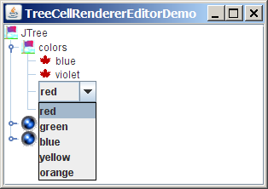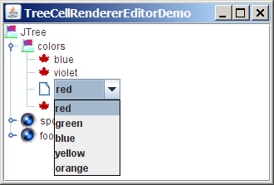

(a) (b)

Figure 40.30
You can supply a custom editor for editing tree nodes.
There are two annoying problems with the editor created in the preceding code. First, it is activated with just one mouse click. Second, it overlaps the node's icon, as shown in Figure 40.30a. These two problems can be fixed by using the DefaultTreeCellEditor, as shown in the following code:

jTree1.setCellEditor

(new javax.swing.tree.DefaultTreeCellEditor(jTree1,
new javax.swing.tree.DefaultTreeCellRenderer(),
new javax.swing.DefaultCellEditor(jcboColor)));
The new editor is shown in Figure 40.30b. Editing using DefaultTreeCellEditor starts on a triple mouse click. The combo box does not overlap the node’s icon.

40.15 Tree Events
JTree can fire TreeSelectionEvent and TreeExpansionEvent, among many other events. Whenever a new node is selected, JTree fires a TreeSelectionEvent. Whenever a node is expanded or collapsed, JTree fires a TreeExpansionEvent. To handle the tree-selection event, a listener must implement the TreeSelectionListener interface, which contains a single handler named valueChanged method. TreeExpansionListener contains two handlers named treeCollapsed and treeExpanded for handling node expansion or node closing.
The following code displays a selected node in a listener class for TreeSelectionEvent:

public void valueChanged(TreeSelectionEvent e) {

TreePath path = e.getNewLeadSelectionPath();

TreeNode treeNode = (TreeNode)path.getLastPathComponent();

System.out.println("The selected node is " + treeNode.toString());
}

Chapter Summary
- JTable has three supporting models: a table model, a column model, and a list-selection model. The table model is for storing and processing data. The column model represents all the columns in the table. The list-selection model is the same as the one used by JList for selecting rows, columns, and cells in a table. JTable also has two useful supporting classes, TableColumn and JTableHeader. TableColumn contains the information on a particular column. JTableHeader can be used to display the header of a JTable. Each column has a default editor and renderer. You can also create a custom editor by implementing the TableCellEditor interface, and you can create a custom renderer by implementing the TableCellRenderer interface.

- Like JTable, JTree is a very complex component with many supporting interfaces and classes. While JTree displays the tree, the data representation of the tree is handled by TreeModel, TreeNode, and TreePath. TreeModel represents the entire tree, TreeNode represents a node, and TreePath represents a path to a node. Unlike the ListModel or TableModel, the tree model does not directly store or manage tree data. Tree data are stored and managed in TreeNode and TreePath. A TreePath is an array of Objects that are vended from a TreeModel. The elements of the array are ordered such that the root is always the first element (index 0) of the array. The TreeSelectionModel interface handles tree node selection. The DefaultTreeCellRenderer class provides a default tree node renderer that can display a label and/or an icon in a node. The DefaultTreeCellEditor can be used to edit the cells in a text field. The TreePath class is a support class that represents a set of nodes in a path.

- JTable and JTree are in the javax.swing package, but their supporting interfaces and classes are all included in the javax.swing.table and javax.swing.tree packages, respectively.

Test Questions
Do the test questions for this chapter online at www.cs.armstrong.edu/liang/intro9e/test.html.

Review Questions

Sections 40.2-40.7
40.1 How do you initialize a table? Can you specify the maximum number of visible rows in a table without scrolling? How do you specify the height of a table cell? How do you specify the horizontal margin of table cells?
40.2 How do you modify table contents? How do you add or remove a row? How do you add or remove a column?
40.3 What is autoresizing of a table column? How many types of autoresizing are available?
40.4 What are the properties that show grids, horizontal grids, and vertical grids? What are the properties that specify the table row height, vertical margin, and horizontal margin?
40.5 What are the default table renderers and editors? How do you create a custom table cell renderer and editor?
40.6 What are the default tree renderers and editors? How do you create a custom tree cell renderer and editor?
40.7 How do you disable table cell editing?

Sections 40.8-40.14
40.8 How do you create a tree? How do you specify the row height of a tree node? How do you obtain the default tree model and tree-selection model from an instance of JTree?
40.9 How do you initialize data in a tree using TreeModel? How do you add a child to an instance of DefaultMutableTreeNode?
40.10 How do you enable tree node editing?
40.11 How do you add or remove a node from a tree?
40.12 How do you obtain a selected tree node?

Programming Exercises

Sections 40.2-40.7
40.1*
(Create a table for a loan schedule) Exercise 31.5 displays an amortization schedule in a text area. Write a program that enables the user to enter or choose the loan amount, number of years, and interest rate from spinners and displays the schedule in a table, as shown in Figure 40.31. The step for loan amount is $500, for number of years is 1, and for annual interest rate is 0.125%.
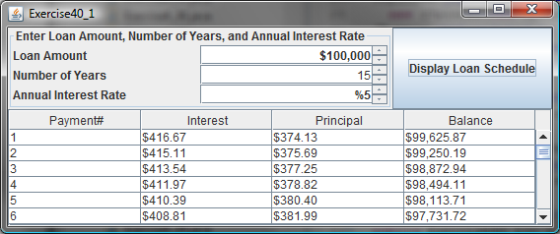

Figure 40.31
The table shows the loan schedule.

40.2*
(Delete rows and columns) Listing 40.6, ModifyTable.java, allows you to delete only the first selected row or column. Enable the program to delete all the selected rows or columns. Also enable the program to delete a row or a column by pressing the DELETE key.

40.3**
(Create a student table) Create a table for student records. Each record consists of name, birthday, class status, in-state, and a photo, as shown in Figure 40.32a. The name is of the String type; birthday is of the Date type; class status is one of the following five values: Freshman, Sophomore, Junior, Senior, or Graduate; in-state is a boolean value indicating whether the student is a resident of the state; and photo is an image icon. Use the default editors for name, birthday, and in-state. Supply a combo box as custom editor for class status.
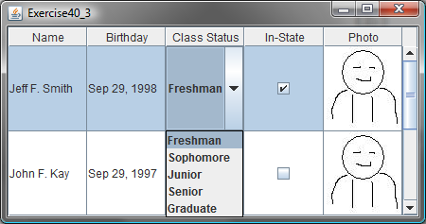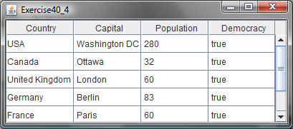
(a) (b)

Figure 40.32
(a) The table displays student records. (b) The data in the file are displayed in a JTable.

40.4*
(Display a table for data from a text file) Suppose that a table named Exercise36_4Table.txt is stored in a text file. The first line in the file is the header, and the remaining lines correspond to rows in the table. The elements are separated by commas. Write a program to display the table using the JTable component. For example, the following text file is displayed in a table, as shown in Figure 40.32b.

Country, Capital, Population, Democracy

USA, Washington DC, 280, true

Canada, Ottawa, 32, true

United Kingdom, London, 60, true

Germany, Berlin, 83, true

France, Paris, 60, true

Norway, Oslo, 4.5, true

India, New Delhi, 1046, true

40.5***
(Create a controller using JTable) In Exercise 35.1, you created a chart model (ChartModel) and two views (PieChart and BarChart). Create a controller that enables the user to modify the data, as shown in Figure 40.33. You will see the changes take effect in the pie-chart view and the bar-chart view. Your exercise consists of the following classes:
- The controller named ChartController. This class uses a table to display data. You can modify the data in the table. Click the Insert button to insert a new row above the selected row in the table, click the Delete button to delete the selected row in the table, and click the Update button to update the changes you made in the table.
- The class MyTableModel. This class extends DefaultTableModel to override the getColumnClass method so that you can use the JTable’s default editor for numerical values. This class is same as in Listing 40.7.
- The classes ChartModel, PieChart, and BarChart from Exercise 35.1.
- The main class Exercise36_5. This class creates a user interface with a controller and two buttons, View Pie Chart and View Bar Chart. Click the View Pie Chart button to pop up a frame to display a pie chart, and click the View Bar Chart button to pop up a frame to display a bar chart.

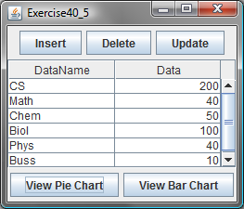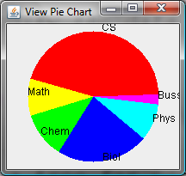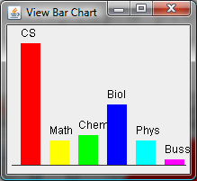

Figure 40.33
You can modify the data in the controller. The views are synchronized with the controller.

Sections 40.8-40.14
40.6*
(Create a tree for book chapters) Create a tree to display the table of contents for a book. When a node is selected in the tree, display a paragraph to describe the selected node, as shown in Figure 40.34.
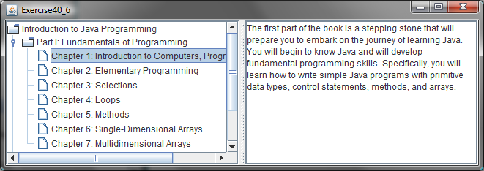

Figure 40.34

The content of the node is displayed in a text area when the node is clicked.

40.7*
(Store and restore trees) Modify Listing 40.16, ModifyTree.java, to add two buttons, as shown in Figure 40.35 to store and restore trees. Use the object I/O to store the tree model.
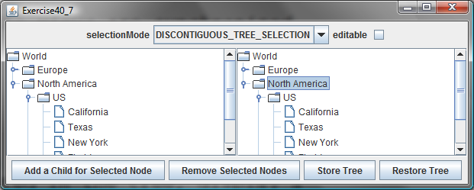

Figure 40.35

You can store tree data to a file and restore them later.

40.8*
(Traverse trees) Create a tree using the default JTree constructor and traverse the nodes in breadth-first, depth-first, preorder, and postorder.

40.9***
(File explorer) Use JTree to develop a file explorer. The program lets the user enter a directory and displays all files under the directory, as shown in Figure 40.36.
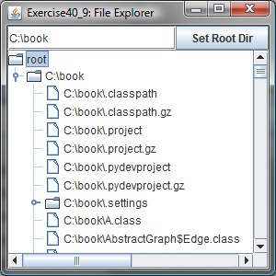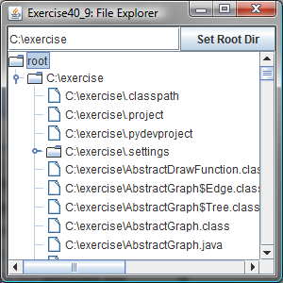

Figure 40.36

The file explorer explores the files in a directory.

40.10**
(Add and delete tree nodes using the INSERT and DELETE keys) Modify Listing 40.16, ModifyTree.java, to add a new child node by pressing the INSERT key, and delete a node by pressing the DELETE key.
40.11*
(Find tables and show their contents) Revise Programming Exercise 33.6 to display the table contents in a JTable rather than in a text area.

